NMR-Spectroscopy in Polymer Science

Introduction and Overview

The increase of computer power and the development of sophisticated pulse-programs during the recent decades has made the solid-state NMR one of the most tools in polymer science making incredible use of the facilities the Hamiltonean offers. The Nobel-laureate R. R. Ernst once called the potential “close to magic”. Solid-state NMR is unprecedented in its structural specificity using the innocuous, definite label present in all polymers.
Interactions in the solid state result in a significant line broadening of the NMR-spectra in the solid state, at the same time, however, there are many information hidden by this effect. Many experimental techniques on the hardware as well as on the software side have been developed to reduce or eliminate these interactions to obtain narrow resonance-lines and spectra close to solution spectra. On the other side interactions like the dipolar coupling (DC) or the chemical shift anisotropy (CSA) are exactly the sources of information about the conditions in the solid state. The methods which have been developed to extract these informations from the NMR-experiments are e. g.: multi-dimensional spectroscopy (2D-and 3D-techniques) that allow to correlate a structural parameter (chemical shift) with parameters that carry information about dynamic and order (CSA), .

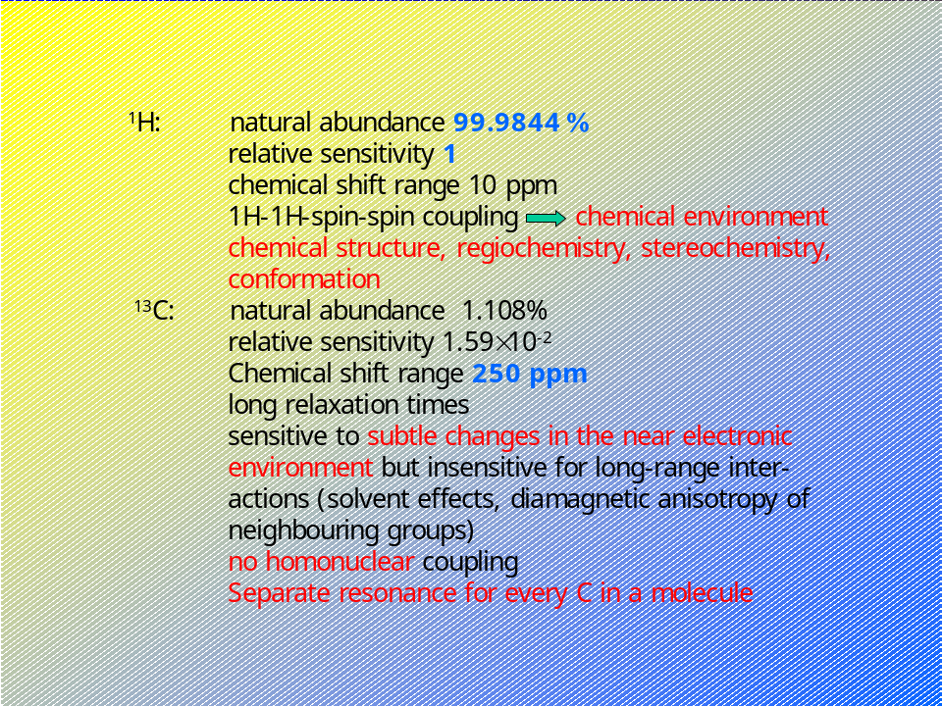1

The information which can be extracted from NMR experiments ranges from rather qualitative data such as connectivities of atoms or groups of atoms and the magnetic equivalence of atoms in a compound to quantitative structural values like the J-coupling constant and cross-relaxation rates which provide knowledge about local conformation, distances, bond angle and even local mobility.

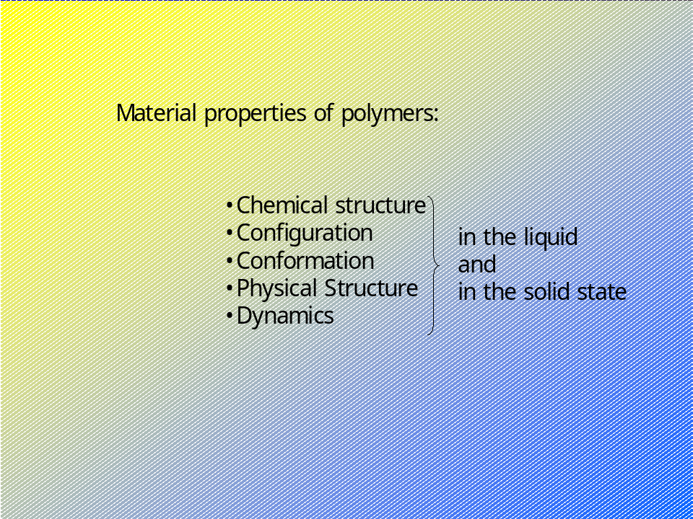2

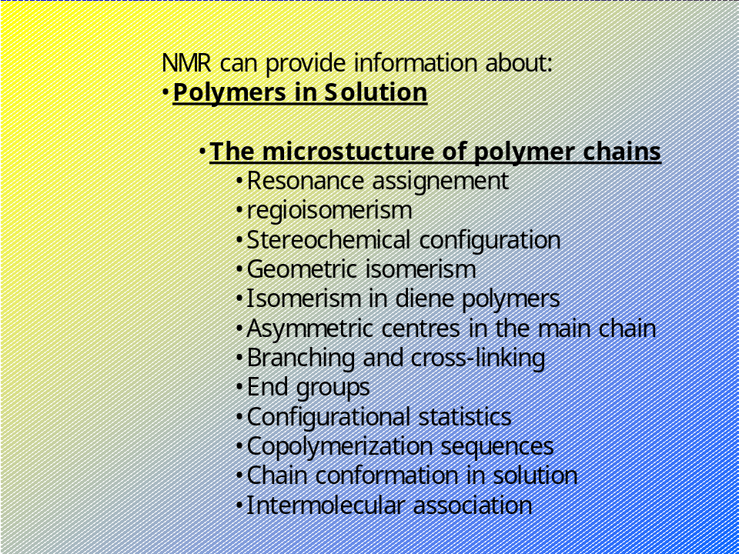3

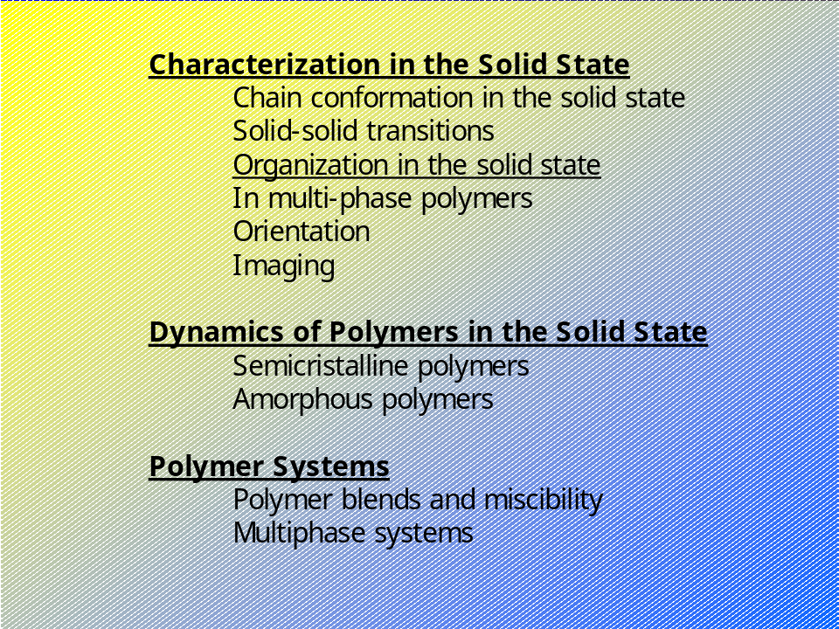4

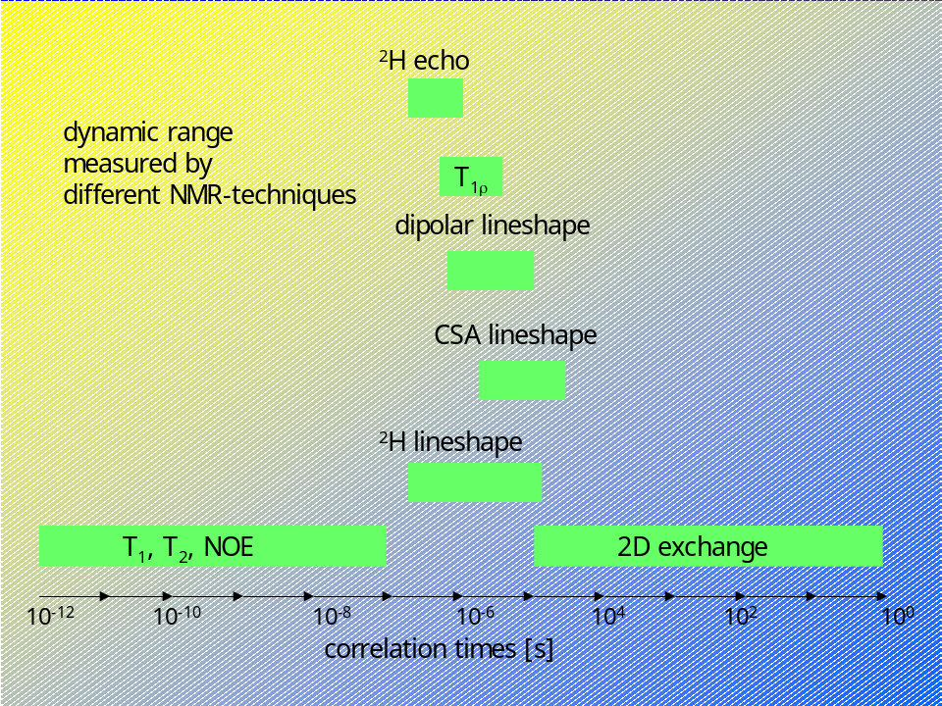5

The development of NMR-spectroscopy comprises 3 major steps:

- The development of high-field superconducting magnets.
- The introduction of fast Fourier transform methods.

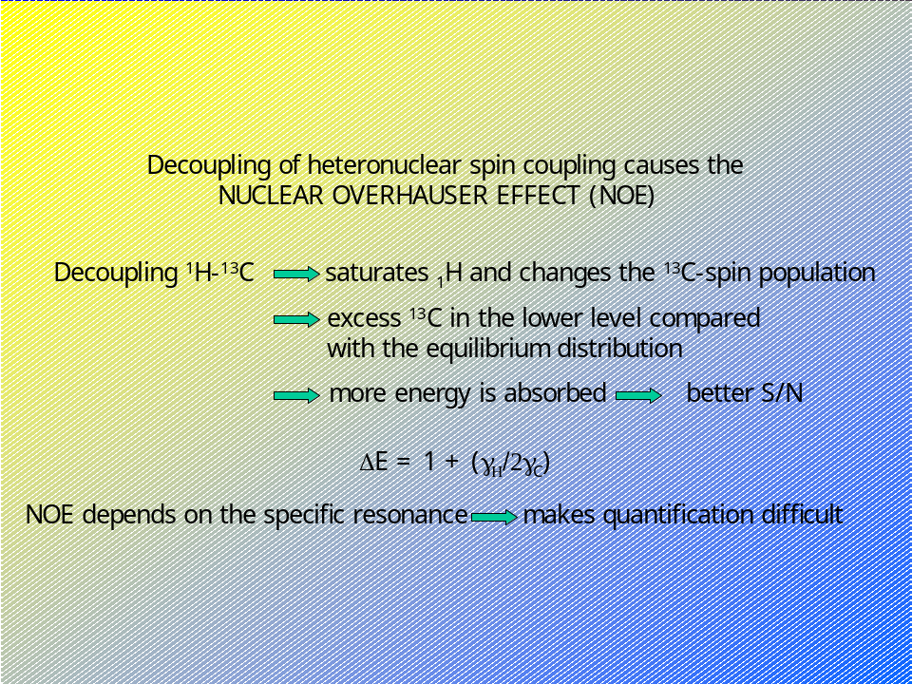6

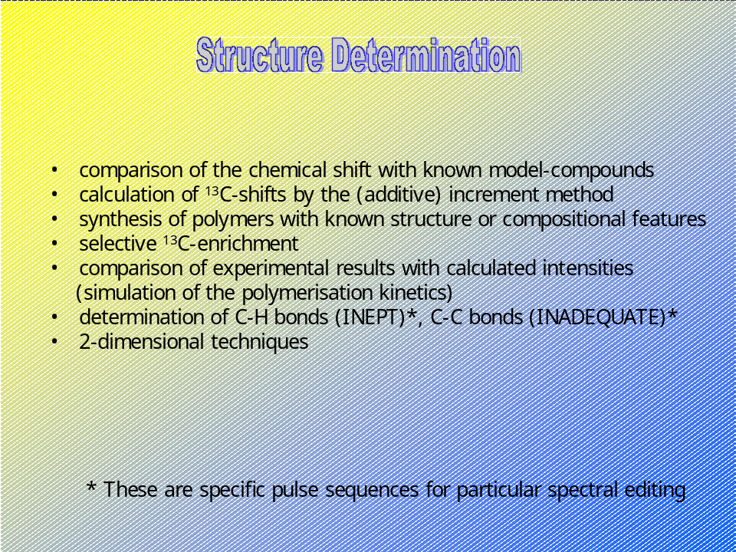7
8

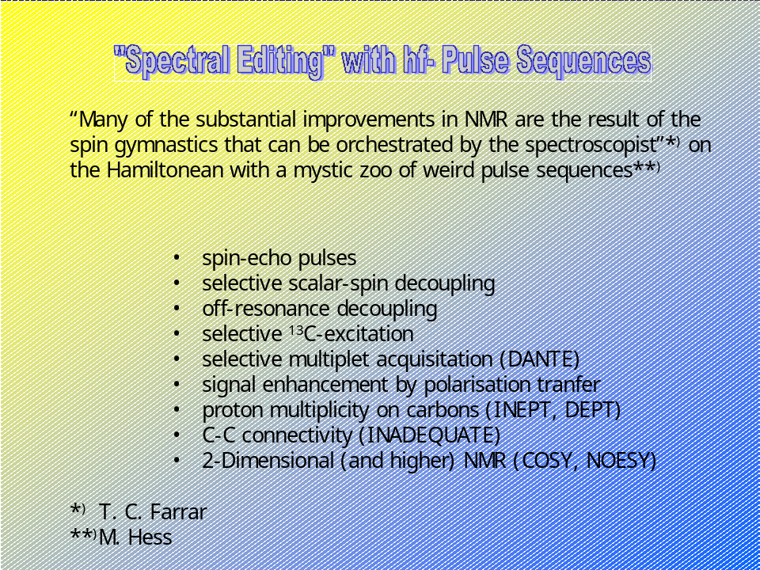9

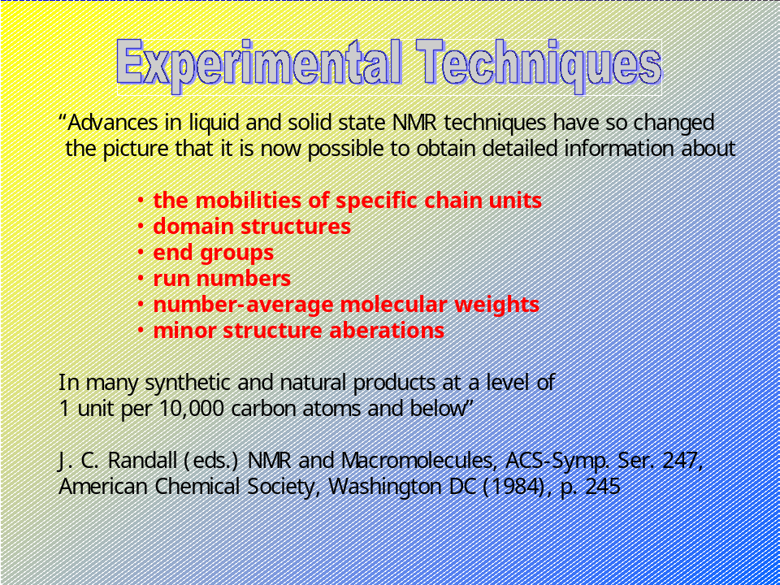10

These have led to an increased sensitivity even to nuclei not exactly abundant but important (such as ¹³C or ¹⁵N) and the ability to manipulate nuclear spins though the pulsed Fourier Transform techniques.
- The development of multi-dimensional techniques by expanding the original Fourier transform concept, first proposed and implemented by Jeener and Ernst for 2D, later by Griesinger³ for a 3rd dimension and NMR-imaging, see for example Blümler and Blümich. For a general review see also Becker et al.

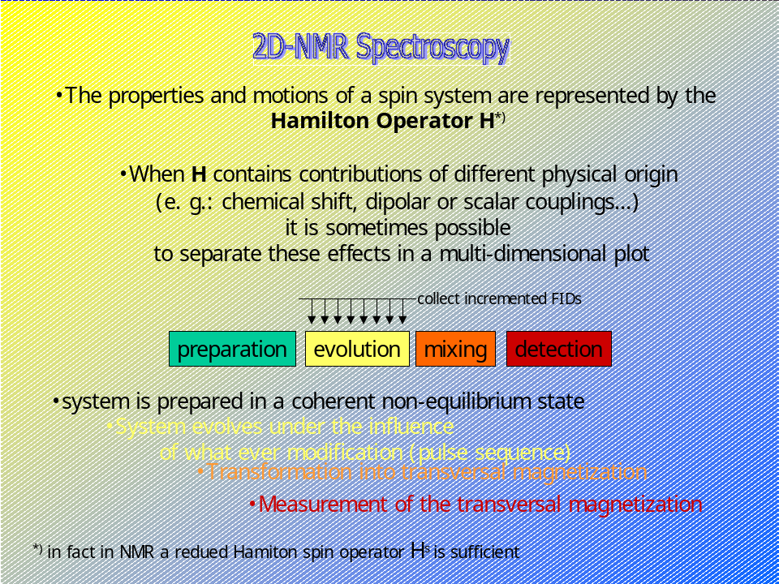11

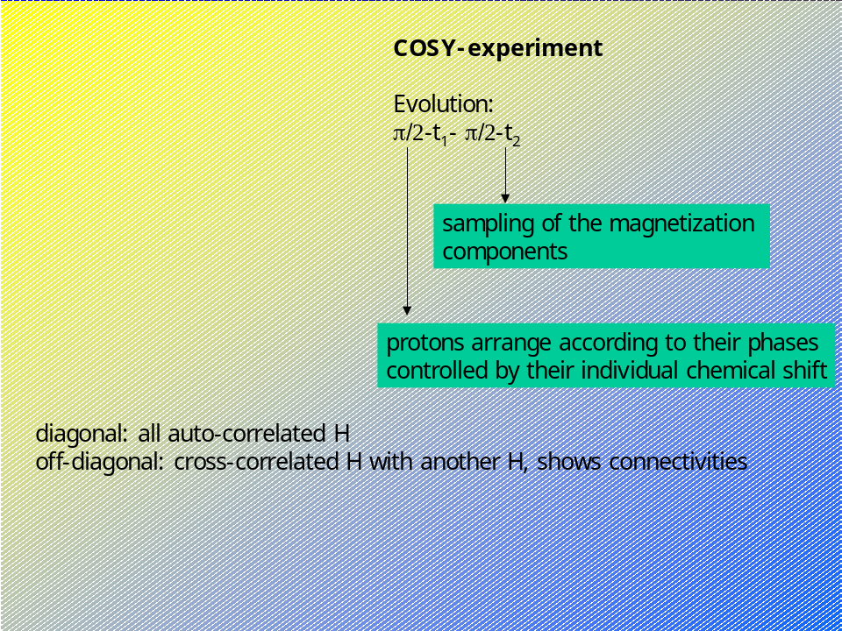12

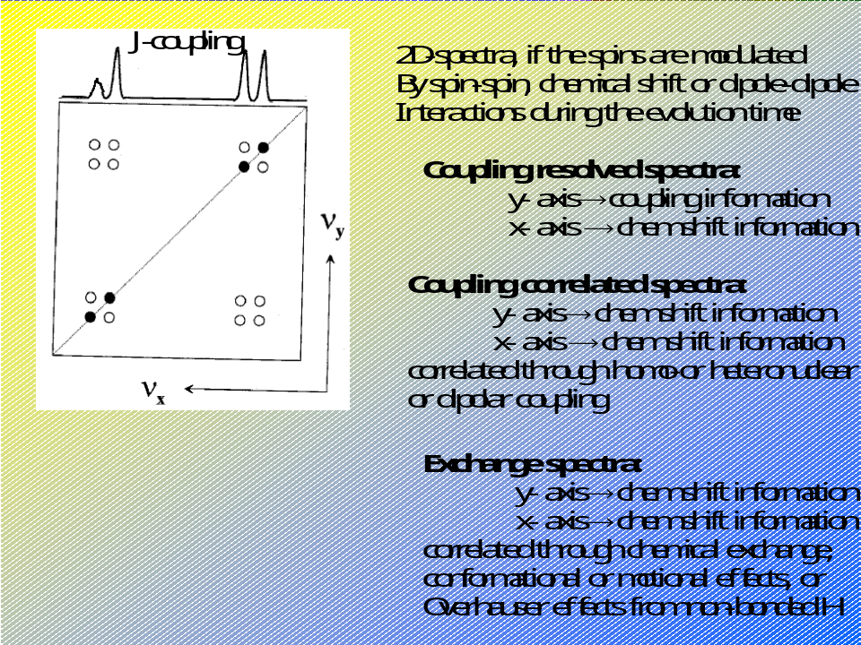13

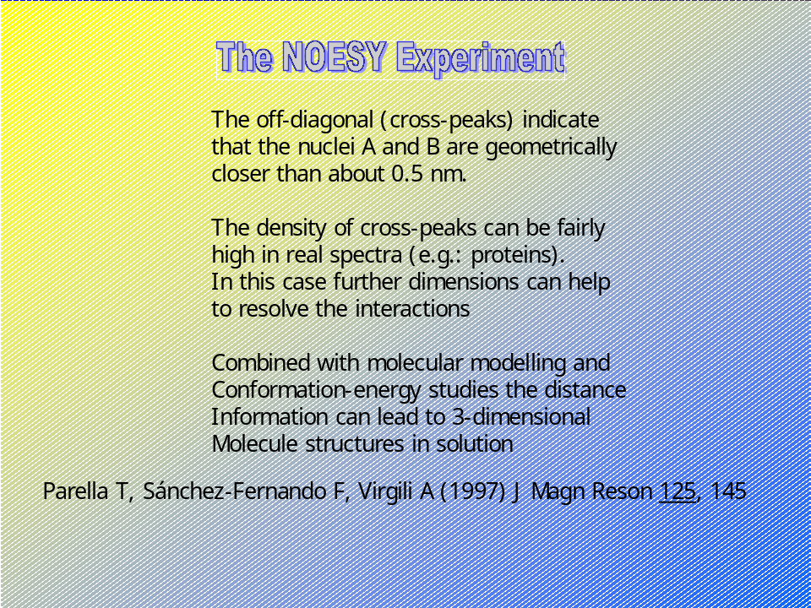14

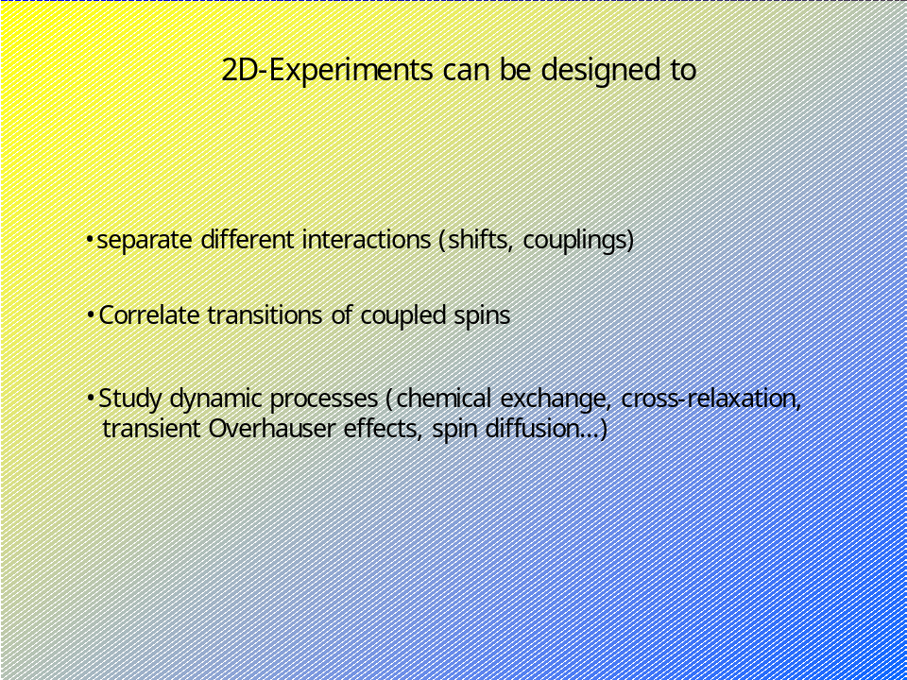15

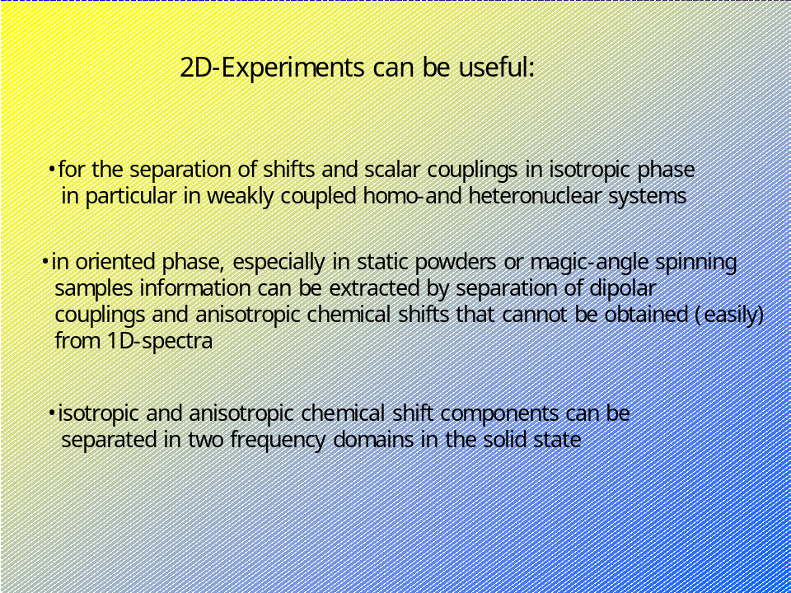16

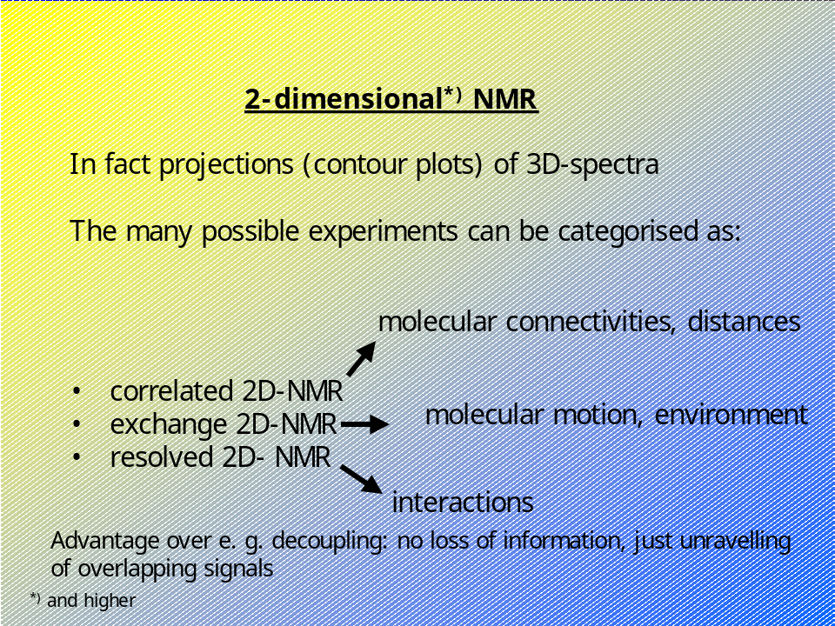17

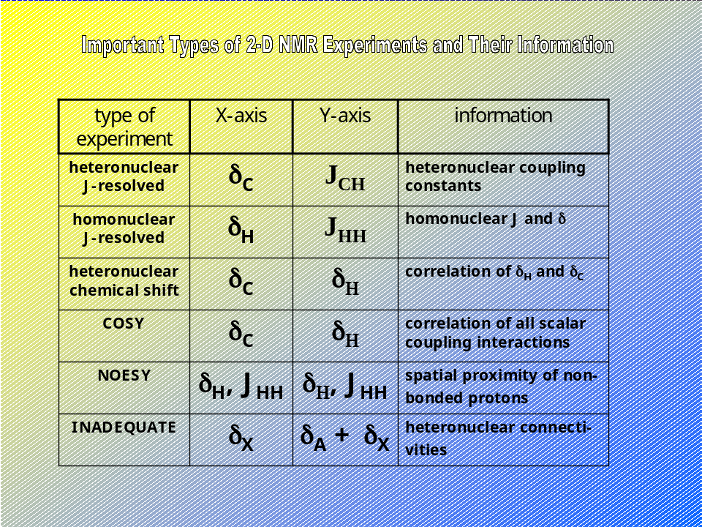18

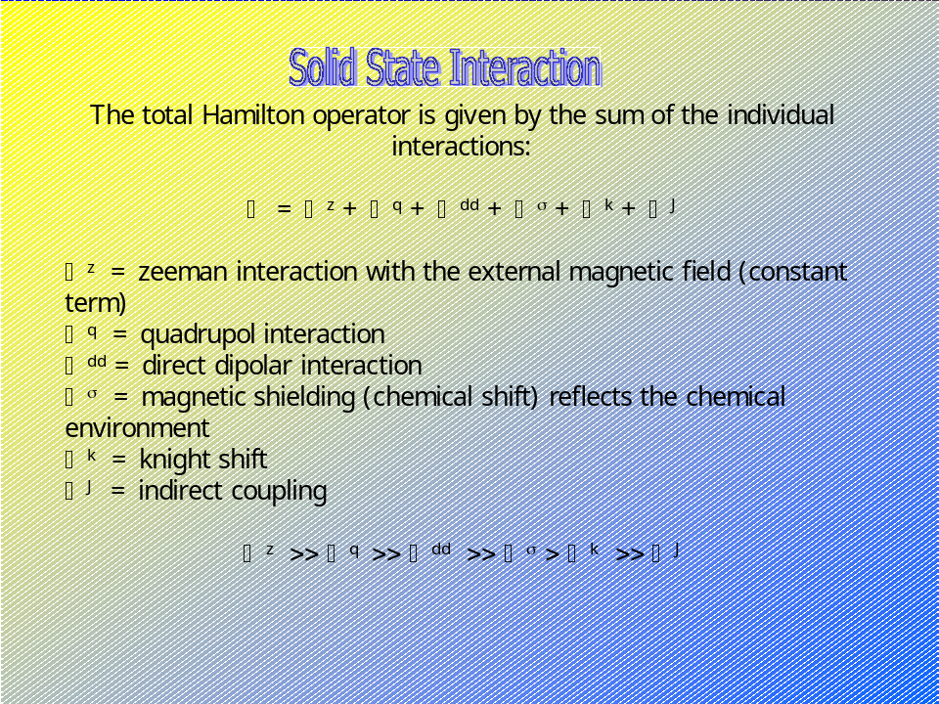19

The first techniques – slow passage (continuous wave) – revealed the major drawback of NMR-spectroscopy, that is its low sensitivity caused by the low quantum energies of the transitions of about 10⁻⁶ eV (1 eV = 1.60218⋅10⁻¹⁹J). Optimisation of the sensitivity could be accomplished in slow passage experiments by high-field spectroscopy, ; the use of large volumes; magnetisation enhancement by the hetero nuclear Overhauser effect, ; cross-polarization in solids, , and in liquids, , , , ; coherence transfer by rf-pulses in solids¹²⁻¹⁴ and in liquids¹⁵⁻¹⁹; indirect resonance detection by electron-nuclear double resonance (ENDOR), internuclear double resonance (INDOR) cross-polarization in the solid^{12, , ,} and in the liquid state^{15, 16}; coherence transfer by rf-pulses, , ; shortening of the longitudinal relaxation by paramagnetic substances;flowing sample techniques to circumvent saturation effects, .
Since there is a basic correlation between the sensitivity s and the measuring time t: s ∝ √t accumulation of spectra and averaging are advantageous, , , , . Slow scans reduce the low-frequency noise³⁵. Fast scans increase the average magnetization. The draw-back of fast scan accumulation, however, is that a distortion of the line shape can lead to a decreasing resolution, . Deconvolution can (at least partially) overcome this problem and is also successfully used in correlation spectroscopy and rapid scan FT-spectroscopy, , . Rapid scan spectroscopy can approach the sensitivity of FT-techniques and has the advantage that selected spectral regions can be scanned.
The development of Pulse-FT-NMR provided a simultaneous, multi-frequency source of excitation, , , . The free-induction decay (FID) is the pulse response of the sample and forms a Fourier couple with the spectrum. With this technique - which was only possible because of the availability of fast, low-priced computers and fast Fourier-transform algorithms - a big step forward was done in sensitivity by recording the response (FID) of a short excitation pulse^{36,} . The disadvantages of the FT-pulse technique are problems with the dynamic range, base-line artefacts, and frequency folding. The inherent advantages of a much higher sensitivity and the absence of peak-shape distortions, however, overcome the disadvantages and have made pulse-FT NMR the preferred NMR technique, , . It is applicable in the solid state¹⁴ (1.22) for high-resolution spectra in solution⁴⁷⁻⁴⁹, and used in transient processes of spin systems such as relaxation experiments, , , , , the study of diffusion processes, and chemical reactions, , .
What basically is done in modern pulse NMR spectroscopy is that the spin Hamiltonean is modified in a way that allows extracting the desired information. This way spectra can be simplified by eliminating selected interactions such as hetero-or homonuclear dipolar couplings. The information content can be increased by introducing specific, additional perturbations. As examples may serve:

- Magic angle sample spinning to eliminate the anisotropic part of the chemical shifts, , ,
- Double-resonance experiments can be used for spin decoupling, ,
- Multiple-pulse methods to remove dipolar couplings between abundant spins in solids^{14,} , , ,
- Spin tickling^{65,}

Conventional NMR considers the frequency response S(ω) of a sample. The response function S depends on two variables ω₁, ω₂ in a double quantum experiment S(ω₁, ω₂). The second variable is frequently an (incremented) parameter. This can be used to create a 2-dimensional (2D) spectrum (which in fact is a three dimensional spectrum displayed as a 2D contour plot). 2D spectra were introduced in 1971 as a two-pulse experiment in the time domain. The general scheme of a 2D-experiment consists of the preparation, the evolution, the mixing and the detection. Two independent magnetizations can evolve (e. g.: ¹H and ¹³C), and the precession coherence is suddenly changed during the mixing period. This can be accomplished by switching the Hamiltonian by one of the many spin-manipulation techniques or through coherence-transfer from one transition to another. The major advantages are:

- Mapping of slow dissipative processes e. g.: cross-relaxation, nuclear Overhauser effects, spin diffusion and slow chemical exchange^{57-59,} , ,
- Determination of correlations, i. e. scalar or dipolar coupling of nuclei
- Straightening-out the spectral overlaps
- Multiple-quantum transitions of various orders of (forbidden) transitions can be resolved because selection rules can be circumvented, , , ,

Basic Principles

Nuclei with an angular momentum can be characterized by the spin quantum number I . If a nuclei then shows a magnetic moment vector μ this is given by

⏐μ⏐= γħ√(I(I+1)

with the z-component
⏐μ_{z}⏐ = γħI_{z}

When isolated nuclei of the same isotope with a magnetic moment μ are exposed to an external magnetic field B₀ most of the spins are oriented parallel with respect to B₀, some are not. If I is the nuclear magnetic spin quantum number of the isotope then there are 2I+1 possible orientations, e. g. two orientations (parallel and anti-parallel) if I=1/2 as in ¹H or ¹³C. The distribution of the spin population among the corresponding energy levels is governed by Boltzmann’s distribution law:

N₁ = N₀ exp(-ΔΕ⁄k_{b}⋅T)

The difference in potential energy between the two orientations is given by the Planck equation

ΔE = h ⋅ν₀ = ħ⋅ω₀ = γ ⋅ħ.⋅B₀

This is the basic equation of NMR.
The vector of the magnetic moment μ rotates around the z-axis with the Larmor frequency ω₀.

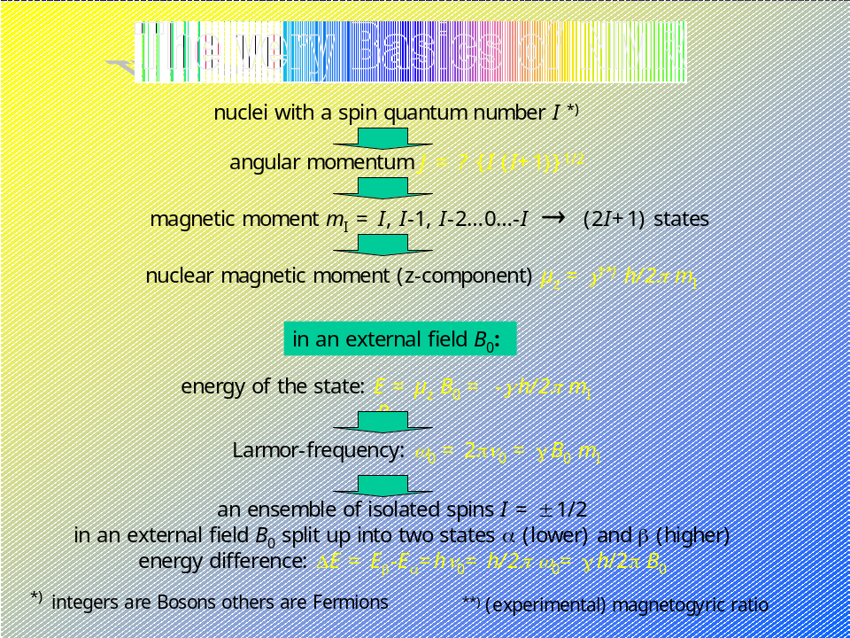20

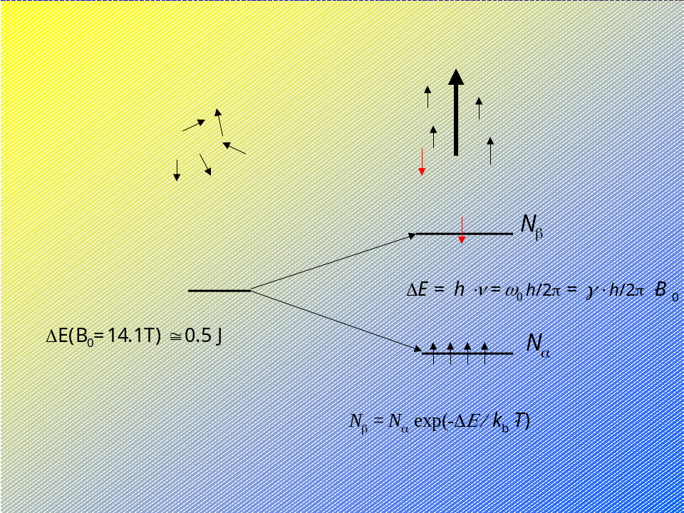21

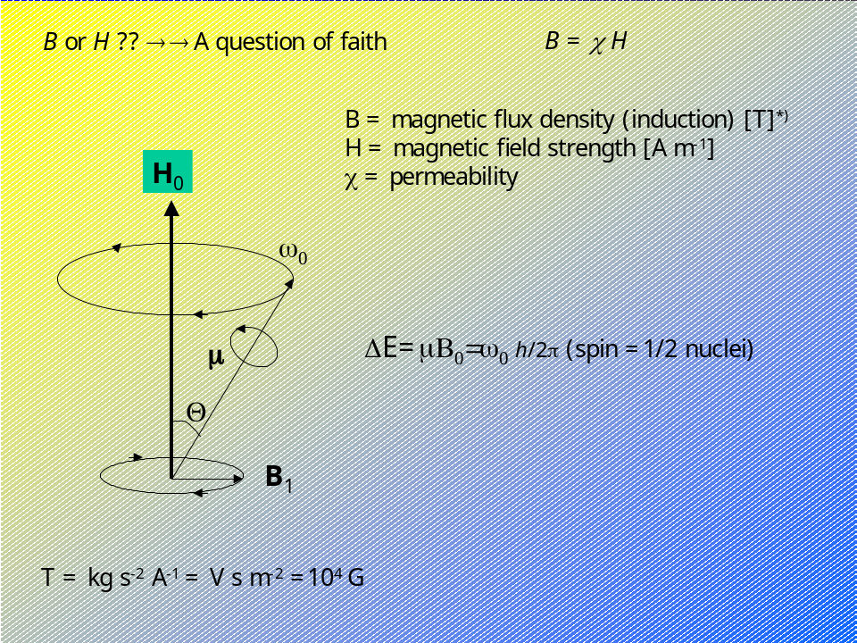22

In an NMR-experiment the energy difference can be supplied by radio frequencies, that means in the MHz-range. The orientation of the nuclear spins results in a macroscopic magnetization of the sample. If the sample is exposed to a radiation with the frequencyν₀ which matches with the energy difference ΔE (B₀) – e.g.: the resonance condition – then ν₀ is absorbed, and the frequency plot of the absorbed photons shows the NMR-spectrum.

N₀, N₁ = number of spins in the ground state (0) respectively in the excited state (1)
k_{b} = 1.380 66⋅10⁻²³ J/K (Boltzmann constant)
h = 6.626 08⋅10⁻³⁴ J⋅s
ħ = h/2π = 1.054 57⋅10⁻³⁴ J⋅s
γ = magnetogyric ratio
ω₀= 2πν (angular frequency)

For ¹H and a frequency of 100 MHz at room temperature the exponential term is:

exp(-ΔΕ⁄k_{b}⋅T) ≅ 1.6 ⋅ 10⁻⁵

Assumed 1 mol of spins and only 1.6 ⋅10⁻⁵ mol of spins contribute to the magnetization. Although the NMR-technique is a rather insensitive analytical method, this disadvantage is by far over-compensated by the advantages that are provided by the specificity and multiplicity of the information which can be gained from NMR-spectroscopy.

Any influence that affects the local field at a nucleus under observation therefore will be reflected by its resonance frequency:
- interaction with other magnetic dipoles in the direct vicinity of a nucleus will cause a shift of its resonance line in the spectrum. This is an interaction through the space which decreases with r ^{–3}.
- the electron cloud that forms a chemical bond also causes a shift of the resonance frequency (shielding or de-shielding)

Interactions usually broaden the NMR resonance lines of a spectrum. In (non-viscous) liquids these interactions are averaged by rapid isotropic motions of the molecules or molecule parts – in polymers by bond rotations of the backbone and the side-chain or groups. The fast isotropic motions average the interactions to zero or to a single finite value representing the average interaction. This is no longer valid in the solid state with the crystalline phases, the frozen thermodynamic non-equilibrium glasses, in ordered phases. It is possible to influence these interactions to a great deal by the experimental technique.

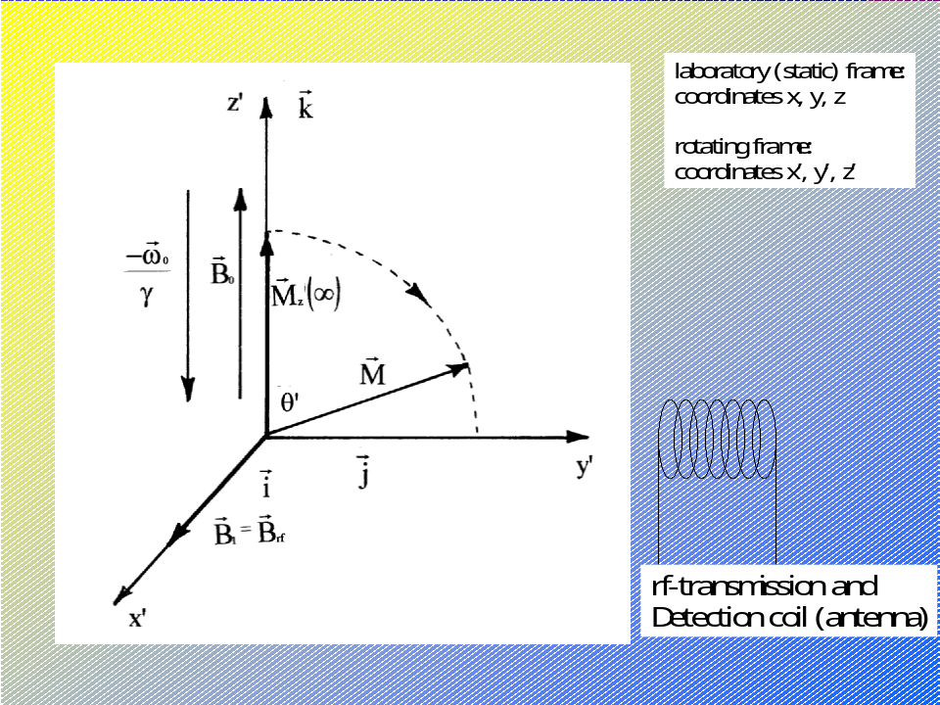23

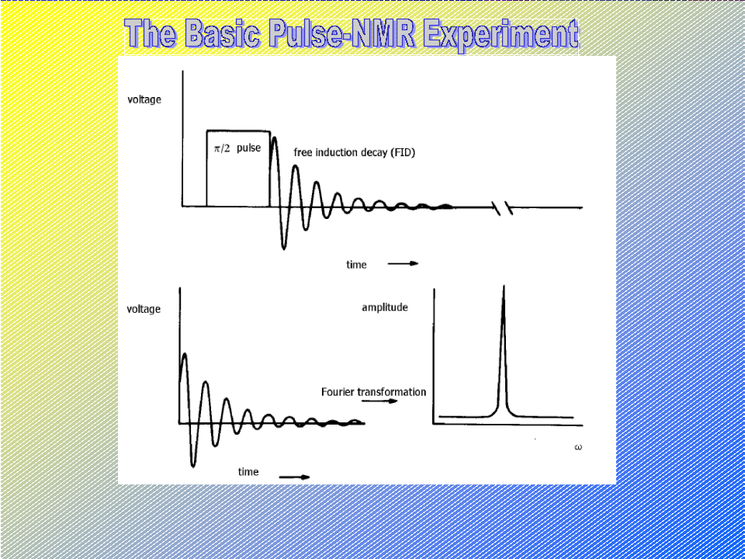24

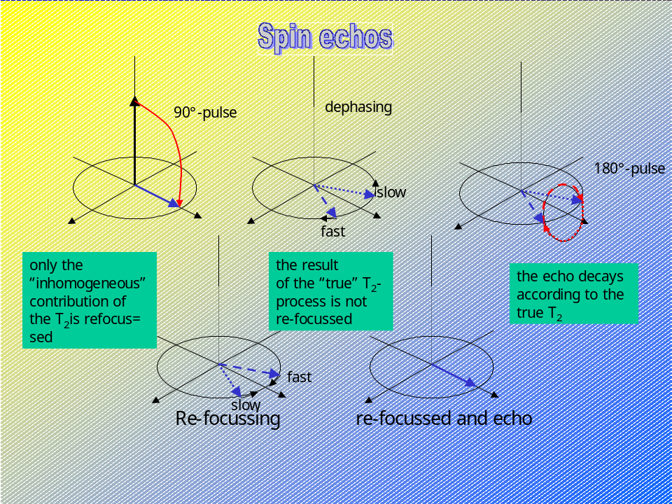25

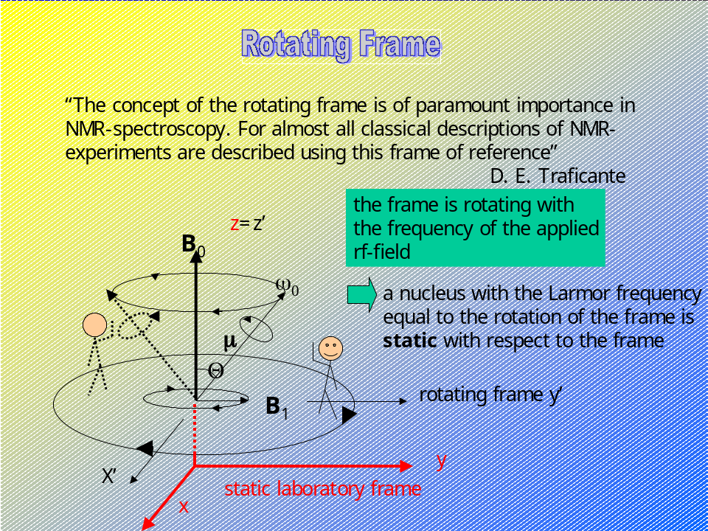26

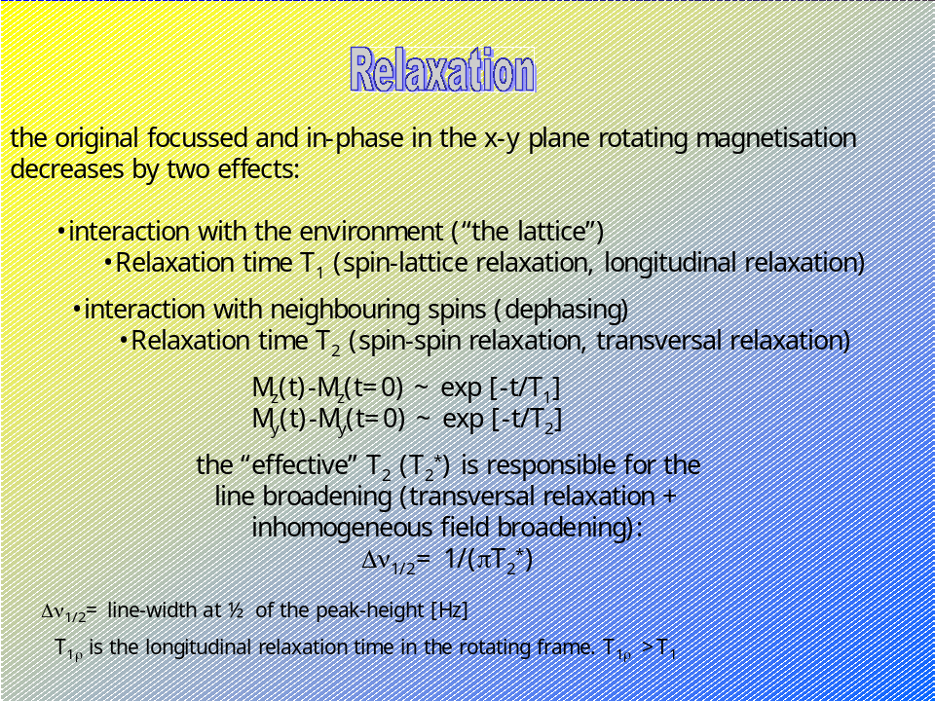27

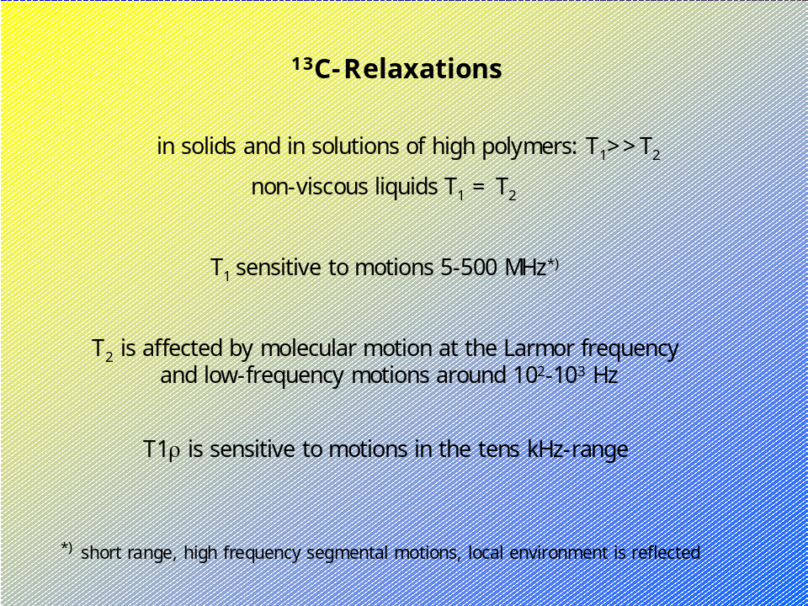28

Types of Interactions

Dipolar Coupling

The magnetic dipoles of the nuclei sense each other through space with a distance law proportional to r⁻³ for static dipoles and r⁻⁶ for rotating dipoles. In ¹H-NMR the interaction is mostly among the protons. In ¹³C-NMR with the low natural abundance of the ¹³C-isotopes the proximity of another ¹³C-isotope within reach of dipolar interaction is negligible in most cases, the dipolar interaction with the proptons, however, cannot. Besides the distance of the dipoles their mutual orientation is also of importance.
The total Hamilton operator is given by the sum of the individual interactions:

 =  ^{z} +  ^{q} +  ^{dd} +  ^{σ} +  ^{k} +  ^{J}

 ^{z} = zeeman interaction with the external magnetic field (constant term)
 ^{q} = quadrupol interaction
 ^{dd} = direct dipolar interaction
 ^{σ} = magnetic shielding (chemical shift) reflects the chemical environment
 ^{k} = knight shift
 ^{J} = indirect coupling

The different interactions rate usually in the order:

 ^{z} >>  ^{q} >>  ^{dd} >>  ^{σ} >  ^{k} >>  ^{J}

The operators have to be separated or the other operators have to be eliminated for observation of a (chemical shift) spectrum.  ^{z} is eliminated by comparison with a standard reference sample, usually TMS.  ^{k} is negligible for the present case. In I = ½ systems the contribution of  ^{q} is usually unimportant. Remains  ^{dd} and  ^{J}.

^{dd} for the interaction between two nuclei i and j consists of a spin operator and a geometrical part, and in the case of carbon and hydrogen the dipolar coupling D of a set of (isolated) ¹³C and ¹H spin pairs is given by:

 ^{dd} = -ħ² γ_{C}γ_{H} 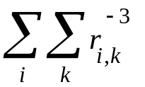(3cos²θ -1)I_{iz} I_{jz}

The result is a double peak. In a real sample, however, the spins are not magnetically isolated and therefore one observes the sum of all couplings in the sample, the powder spectrum (Pake-doublet spectrum) further broadened by additional inhomogeneous broadening. All these interactions produce a ¹³C-solid state spectrum with line width of about 20 Hz.
The dipolar coupling can be eliminated by making the spin- or the geometrical term zero. The second alternative is accomplished by rotating the sample with the "magic angle" θ = 54.74° with respect to the z-direction, the direction of B₀. This can remove weak dipolar interactions. The spin-term can be averaged to zero if the local field of the protons which couples with the ¹³C can be inverted during ½ of the averaging time. This is accomplished by high-power proton decoupling. At the same time the homonuclear H-H coupling term, which is even stronger than the ¹H-¹³C-coupling, has to be averaged in the same way.

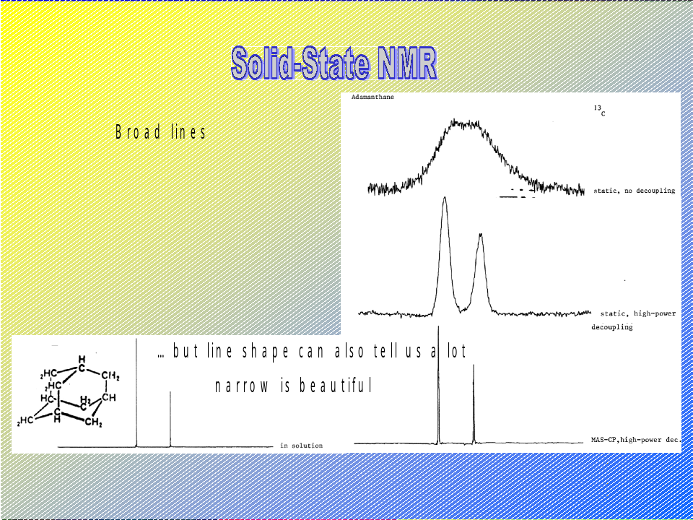29

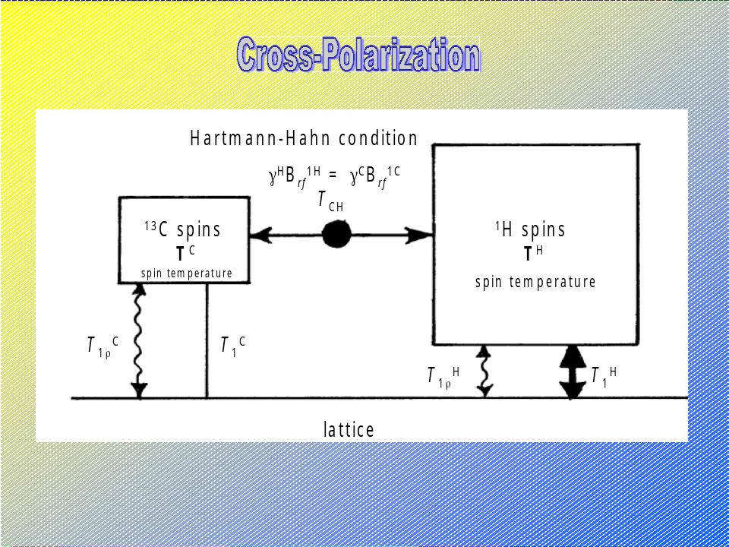30

Chemical Shift Anisotropy

The chemical environment which strongly influences the local field because the orbitals of the electrons are not of spherical symmetry. and can provide information about the orientational order in the sample. The chemical shift can be represented by a second-rank tensor (vector operator).

 ^{σ} = ħ γ σ_{zz} B₀

and σ_{zz} is the projection of the shift tensor onto the direction of B₀. In the case of isotropic averaging σ_{zz(iso)} is the observed value of the chemical shift.

Scalar (Spin-Spin) Coupling

These couplings provide information about the number and identity of the nearest neighbours of a nucleus under observation. They are of great value in ¹H-NMR of solutions, for ¹³C-NMR there is frequently a C-H-decoupling required to make the spectra more transparent. In solid state NMR scalar couplings are of minor value. They have not been resolved for protons, and ¹H-¹³C-couplings are removed with the high-power dipolar decoupling. They can be useful (resolvable) with other I = ½ nuclei.

Diffusion of Small Molecules

The diffusion of small molecules in a bulk polymer or the self-diffusion of molecules can be determined by pulsed Fourier transform gradient experiments (PFEG-NMR).

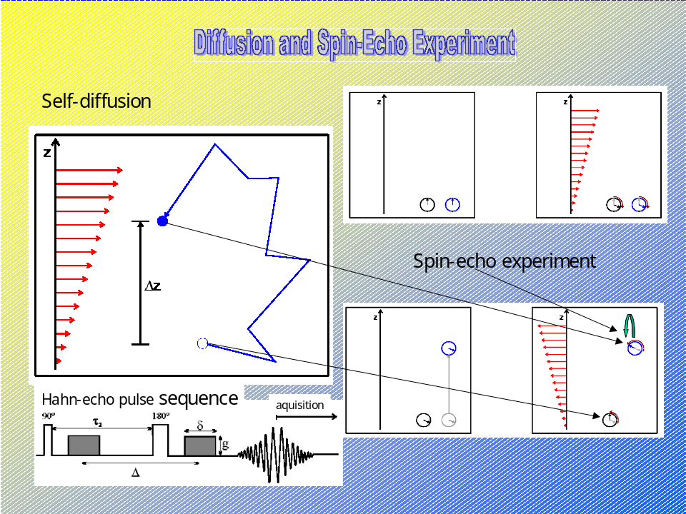31

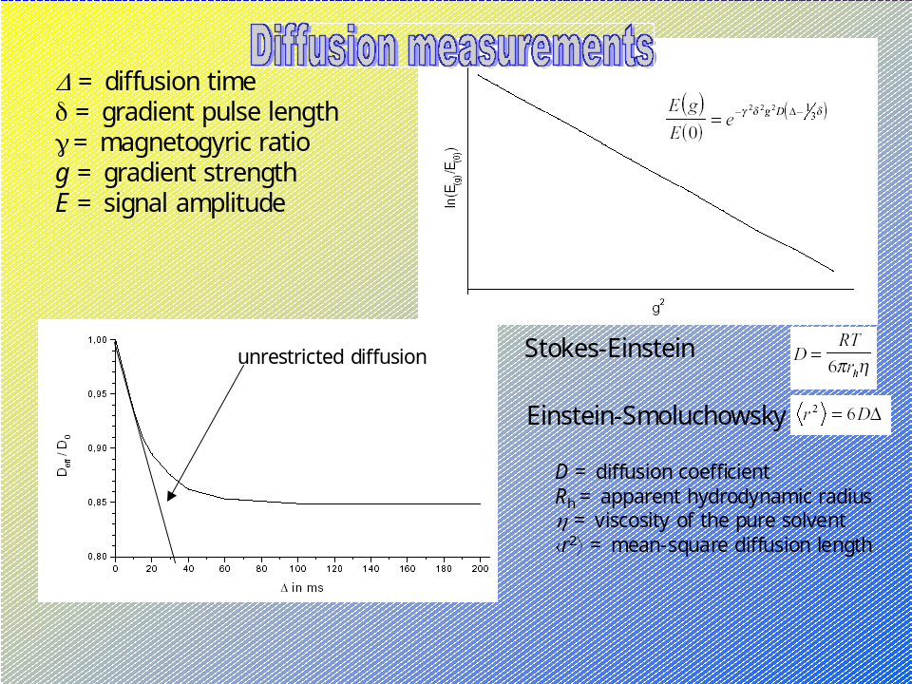32

There are basically two techniques, the Hahn-echo sequence and the stimulated echo pulse sequence available for diffusion measurements. For the meaning of a spin echo see fig 25(echo). The intensity of the echo signal is recorded and plotted versus the gradient strength.

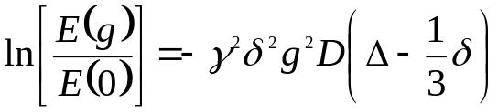

δ = pulse length
Δ = diffusion time
g = gradient strength

The cross-polarization affects the magnetization in z-direction, consequently the Hahn-echo is not affected but the stimulated echo experiment is. Both experiments are influenced by chemical exchange if it is fast enough. Small molecules can also serve as a probe for segmental mobility in polymers, in particular in copolymers comprising different types of segments⁸² . An example for the self-diffusion of a water-soluble modified polymer is given in .

Molecular Mobility in Solid Polymers

Many NMR-parameters such as line-shape and relaxation times are sensitive with respect to local motions. The frequency ranges from 10⁻¹Hz to hundreds of MHz so that at temperatures well above the glass transition temperature fast processes can be monitored through the ¹³C spin-lattice relaxation time T₁ and the NOE as well as the slow motions in the glass e. g. through T_{1ρ}, line-shape analysis, tensorial interactions of the chemical shift anisotropy.
Above the glass transition segmental reorientations are mostly found to occur as conformational jumps. The spreading of such a local motion along the chain can be described by an auto-correlation function,.
It has been demonstratedthat a combination of high-resolution solid state NMR from different types of experiments with other techniques such as dielectrical and mechanical relaxation can sum up to a precise description of the local dynamics in a glassy polymer system and secondary relaxations can be identified described and attributed to the motion of groups or segments⁸⁴.

Orientation in Solid Polymer Systems

Comparison of static and rotating solid state spectra at different sample orientation to B₀ with a number of different techniques allows the determination of the microscopic chain orientation in macroscopically oriented samples such as fibres, film, frozen liquid crystalline structures etc., , . In contrast to X-ray scattering techniques, NMR is in particular suited to analyse weakly ordered systems. The molecular orientation is usually described in terms of an orientation distribution function. The order parameter(s) are the moments of the Legendre polynom of the orientation distribution function. The well-known (temperature-dependent) order parameter ⟨s⟩ used to characterize the state of order of a liquid crystal, for example, is the second moment. Wideline-spectra can be used as well as the analysis of the spinning side-bands which can be observed in MAS-experiments, .

Bibliography

NMR-Spectroscopy

- Veeman W S (1997) Geoderma 80, 225
- Fyfe C A (1983) Solid-State NMR for Chemists, CFC, Guleph, Canada
- Mehring M (1983) Priniples of High Resolution NMR in Solids, Springer, Berlin
- Ernst R R, Bodenhausen G, Wokaun A (1987) Principles of Magnetic Resonance in One-and Two-Dimensions, Clarendon Press, Oxford
- Bertini I, Molinari H, Niccolai N (eds) (1991) NMR and Biomolecular Structure, Wiley-VCh, Weinheim
- Koenig J L (1992) Spectroscopy of Polymers, ACS, Washington DC
- Ibbett R N (ed) (1993) NMR Spectroscopy of Polymers, Blackie Academic & Proffessional (Chapman & Hall) London
- Diehl P, Fluck E, Günther H, Kosfeld R, Seelig J (eds) (1989) NMR-Basic Principles and Progress 21, Structure and Dynamics of Bulk Polymers by NMR-Methods, Springer, Berlin
- Diehl P, Fluck E, Günther H, Kosfeld R, Seelig J (eds) (1994) NMR-Basic Principles and Progress 30, Solid-State NMR I, Springer, Berlin
- Diehl P, Fluck E, Günther H, Kosfeld R, Seelig J (eds) (1994) NMR-Basic Principles and Progress 31, Solid-State NMR II, Springer, Berlin
- Diehl P, Fluck E, Günther H, Kosfeld R, Seelig J (eds) (1994) NMR-Basic Principles and Progress 32, Solid-State NMR III, Spriner, Berlin
- Grant D M and Harris R K (eds) (1996) Encyclopedia of Nuclear Magnetic Resonance, Wiley, Chicester
- Schmidt-Rohr K, Spiess H-W (1994) Multidimensional Solid-State NMR and Polymers, Acad. Press, New York
- Rao N B D, Kemple M D (eds) (1996) NMR as a Structural Tool for Macromolecules, Plenum Press, New York
- Bovey F A, Mirau P A (1996) NMR of Polymers, Acad. Press, New York
- Ernst R R, Bodenhausen G, Wokaun A (1986) Principles of Nuclear Magnetic Resonance in One and Two Dimensions, Oxford Science Publications, Oxford UK
- Noggle J H, Schirmer R E (1971) The Nuclear Overhauser Effect, Acad Press New York
- Kimmich R (1997) NMR-Tomography, Diffusometry, Relaxometry, Springer, Berlin
- Veeman W S, Maas W E J R (1994) in Diehl P, Fluck E, Günther H, Kosfeld R, Seelig J (eds) (1994) NMR-Basic Principles and Progress 32, 127 Springer, Berlin

References

This again shows the importance of certain coincidences for a particular technological advance. As in the early years of electrical engineering the invention of insulating thermosets came just at the right time to boost this field and later electronics, the development of the highly sophisticated spectroscopic methods are unthinkable without the coincidence of superconductors and fast and cheap computers.
A quantum mechanical spin can only in a very simple picture be identified with a "nuclear top"
unfortunately, the averaging is not always isotropic, not even in solution
Mehring M (1983) Priniples of High Resolution NMR in Solids, Springer, Berlin
Ernst R R, Bodenhausen G, Wokaun A (1987) Principles of Magnetic Resonance in One-and Two-Dimensions, Clarendon Press, Oxford
Griesinger C, Sørensen O W, Ernst R R (1987) J Magn Reson 73: 574
Jeener J (1971) Ampere International Summer School, Blasko Polje, Yugoslavia
Aue W P, Bartholdi E, Ernst R R (1976) J Chem Phys 64: 2229
Blümler P, Blümich B (1994) in: Diehl P, Fluck E, Günther H, Kosfeld R, Seelig J (eds) (1994) NMR-Basic Principles and Progress 32, Solid-State NMR III, Spriner, Berlin, p.209
Becker E D, Fisk C L, Khetrapal C L (1996) in Grant D M and Harris R K (eds) Encyclopedia of Nuclear Magnetic Resonance Vol. 1, Wiley, Chicester, p. 1
Nelson F A, Weaver H E (1964) Science 146, 223
Hoult D I, Richards R E (1976) J Magn Reson 24, 71
Paul L G, Grant J (1964) J Am Chem Soc 86, 2977
Noggle J H, Schirmer R E (1971) The Nucler Overhauser Effect, Chemical Applications, Acad press, New York
Hartmann S R, Hahn E L (1962) Phys Rev 128, 2042
Pines A, Gibby M G, Waugh J S (1973) J Chem Phys 59, 569
Mehring M (1983) High Resolution NMR Spectroscopy in Solids, Springer, Berlin
Maudsley A A, Müller L, Ernst R R (1977) J Magn Reson 28, 463
Müller L, Ernst R R (1979) Mol Phys 38, 963
Bertrand R D, Monitz W B, Garroway A N, Chingas G C (1978) J Magn Reson 32, 465
Bertrand R D, Monitz W B, Garroway A N, Chingas G C (1978) J Amer Chem Soc 100, 5227
Chingas G C, Garroway A N, Bertrand R D, Monitz W B (1978) J Chem Phys 74, 127
Feher G (1956) Phys Rev 103, 834
Baker E B, Burch L W, Root G N (1963) Rev Sci Instr 34, 243
Mansfield P, Grannell P K (1971) J Phys C4, L 197
Brunner P, Reinhold M, Ernst R R (1980) J Chem Phys 73, 1086
Reinhold M, Brunner P, Ernst R R (1980) J Chem Phys 74, 184
Maudsley A A, Ernst R R (1977) Chem Phys Lett 50, 3689
Bodenhausen G, Ruben D J (1980) Chem Phys Lett 69, 185
Bax A, Griffey, R G, Hawkins B L (1983) J Magn Reson 55, 301
Gutowsky H S, Tai J C, J Chem Phys 39, 208
Suryan G (1951) Proc Ind Acad Sci A33, 107
Zhernovoy A I, Latyshev G D (1965) Nuclear Magnetic resonance in a Flowing Liquid, Consultants Bureau, New York
Klein M P, Barton G W (1963) Rev Sci Instr 34, 754
Laszlo P, Schleyer P R (1963) J Am Chem Soc 85, 2017
Allen L C, Johnson L F (1963) J Am Chem Soc 85, 2668
Jardetsky N G, Wade N G, Fisher J J (1963) Nature 197,183
Ernst R R (1965) Rev Sci Instr 36, 1689
Ernst R R (1966) Adv Magn Reson 2, 1
Ernst R R, Anderson W A (1965) Rev Sci Instr 36, 1696
Dadok J, Sprecher R F (1974) J Magn Reson 13, 243
Gupta R K, Ferretti J A, Becker E D (1974) J Magn Reson 13, 275
Ferretti J A, Ernst R R (1974) J Chem Phys 65, 4283
Zadeh L A, Desoer C A (1963) Linear System Theory, McGraw Hill, New York
Guillemin E A (1963) Theory of Linear Physical Systems, Wiley, New York
Brown B M (1965) The Mathematical Theory of Linear Systems, Chapman & Hall, London
Bogart T F (1984) Basic Concepts in Linear Systems: Theory and Experiments, Wiley, New York
Lowe I J, Norberg R E (1957) Phys Rev 107, 46
Ernst R R, Anderson W A (1966) Rev Sci Instr 37, 93
Farrar T C, Becker E D (1971) pulse and Fourier Transform NMR, Acad Press, New York
Shaw D (1984) Fourier Transform NMR Spectroscopy, Elsevier, Amsterdam
Martin M L, Delpuech J-J, Martin G J (1980) Practical NMR Spectroscopy, Heyden, London
Hahn E L (1950)Phys Rev 80, 580
Carr H Y, Purcell E M (1954) Phys Rev 94, 630
Vold R L, Waugh J S, Klein M P, Phelps D E (1968) J Chem Phys 48, 3841
Freeman M, Hill H D (1975) in: Jackman L M, Cotton F A (eds) Dynamic NMR Spectroscopy, Acad Press, New York
Vold R L, Vold R R (1978) Progr. NMR Spectrosc 12, 79
Stejskal E O, Tanner J E (1965) J Chem Phys 42, 288
Kimmich R (1997) NMR-Tomography, Diffusometry, Ralaxometry, Springer, Berlin
Gutowsky R L, Vold R L, Wells E J (1965) J Chem Phys 43, 4107
Jackman L M, Cotton F A (eds) Dynamic NMR Spectroscopy, Acad Press, New York
Kaplan J I, Fraenkel G (1980) NMR of Chemically Exchanging Systems Acad Press, New York
Andrew E R, Bradbury A, Eades R G (1973) J Chem Phys 59, 3740
Lowe I J (1959) Phys Rev Lett 2, 285
Schaefer J, Stejscal (1976) J Am Chem Soc 98, 1031
Maricq M, Wagh J S (1979) J Chem Phys 70, 3300
Bloom A L, Shoolery J N (1955) 97, 1261
Hoffman R A, Forsen S (1966) Progr NMR Spectrosc 1, 15
Ernst R R (1966) J Chem Phys 45, 3845
Haeberlen U (1976) High resolution NMR in Solids, Adv Magn Reson Suppl 1
Waugh J S, Huber L M, Haeberlen U (1968) Phys Rev Lett 20, 180
Mansfield P, Orchard M J, Stalker D C, Richards K H B (1973) Phys Rev B7, 90
Rihm W K, Elleman D D, Vaughan R W (1973) J Chem Phys 59, 3740
Freeman R, Anderson W A (1962) J Chem Phys 37, 2053
Aue W P, Bartholdi, Ernst R R (1976) J Chem Phys 64, 2229
Meier B H, Ernst R R (1979) J Am Chem Soc 101, 6441
Jeener J, Meier B H, Ernst R R (1979) J Chem Phys 71, 4546
Kumar A, Ernst R R, Wüthrich K (1980) Biochem Biophys Res Comm 95, 1
Yatsiv S (1952) Phys rev 113, 1522
Anderson W A, Freeman R, Reilly C A (1963) J Chem Phys 39, 1518
Musher J I (1964) J Chem Phys 40, 983
Bodenhausen G (1983) Progr NMR Spectrosc 14, 137
Weitekamp D P (1983) Adv Magn Reson 11, 111
Otting G (1997) Prog Nucl Magn Reson Spectrosc 31, 259-285
Horstmann M, Urbani M, Veeman W S (2003) Macromolecules 36, 6797
Hess M, Jo B-W, Zähres M (2003) Mater. Sci. Innov. 7, 178
Lauprêtre F (1993) in: Ibbett R N (ed) NMR Spectroscopy of polymers, Blackie Academic & Professional, London, p 198 ff
Hall C K, Hellfand E (1982) J Chem Phys 77, 3275
Viovy J L, Monnerie L, Brochon J C (1983) Macromolecules 16, 1845
Jelinski L W, Dumais J J, Watnick P I, Engel A K, Sefcik M D (1983) Macromolecules 16, 409
Nakagawa M, Horii F, Kitamaru (1990) Polymer 31, 323
Bax A, Szeverenzi N M, Maciel G C (1983) J Magn Reson 55, 494
Yang Y, Hagemeyer A, Zemke K, Spiess H W (1990) J Chem Phys 11, 7740
Ward I M (1975) Structure and Properties of Oriented Polymers, Applied Science, London
Wiesner U, Schmidt-Rohr C, Boeffel C, Pawelzik U, Spiess H W (1990) Adv Materials 2, 484
Harbison G S, Vogt V-D, Spiess H W (1987) J Chem Phys 86, 1206
Tang P, Santos R A, Harbison G S (1989) Adv Magn Reson 13, 225

