IR-Spectroscopy in Polymer Science

IR-spectroscopy is probably the oldest of the spectroscopic methods used in polymer science. It is basing of the analysis of molecular vibrations. It can be subdivided into near-infrared (NIR), medium-infrared (MIR), and Raman-spectroscopy.
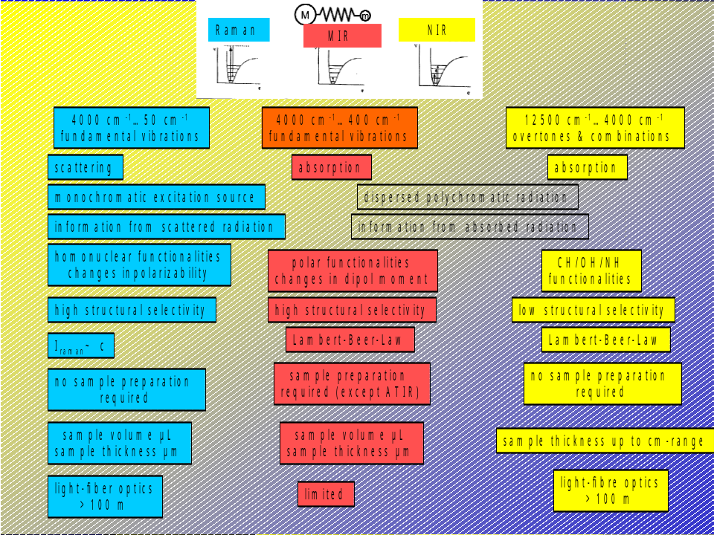
A multitude of techniques are available such as microscopic techniques, measurements in reflection, at high temperatures and low temperatures, solid, liquid (and gaseous) samples, on large and on micro-samples. Even only a few scattered photons can be determined with high-end CCD-detectors.

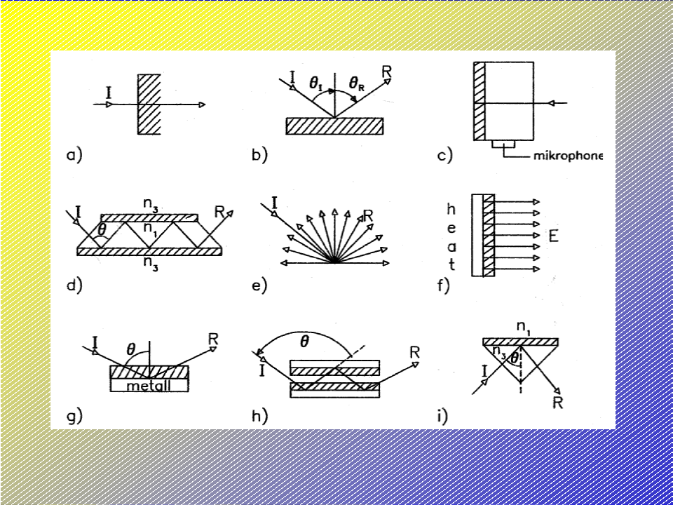
In particular in polymer science it is the translational periodicy of the macromolecules which creates collective motions and phonons which are detectable by Raman spectroscopy. The stereochemical, conformational structure, and symmetry properties give rise for characteristic and specific bands. Starting from only a few basic concepts a real treasure of chemical and physical information can be drawn from IR-spectroscopy, see for example Lin and Brown, who have demonstrated the determination of fifteen properties of water by NIR.
The simplest application is just the identification of a material, in particular under the scope of this short course, the identification of polymer classes. There is a simple flow chart that can give a crude overview:
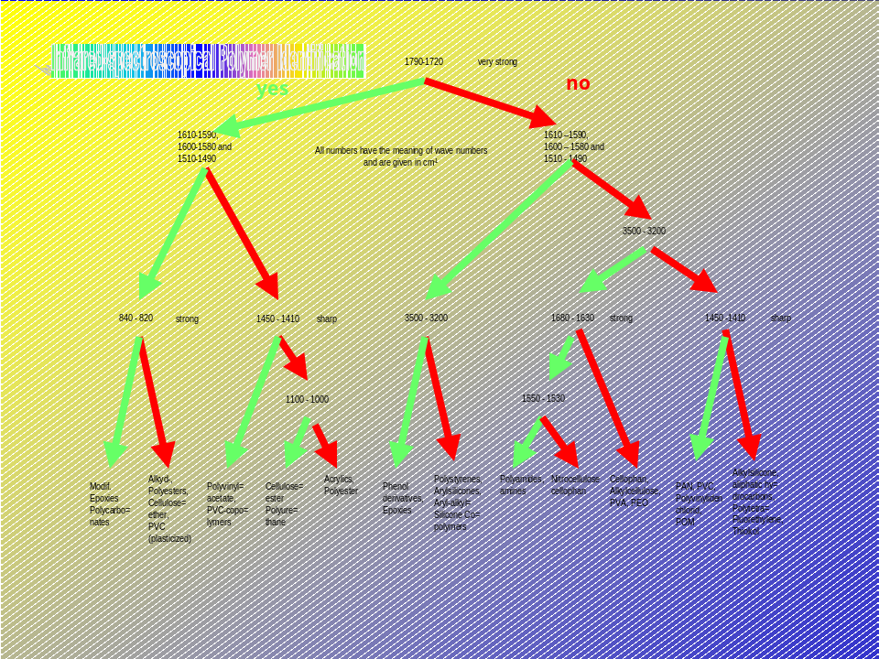

In the following there are some examples:
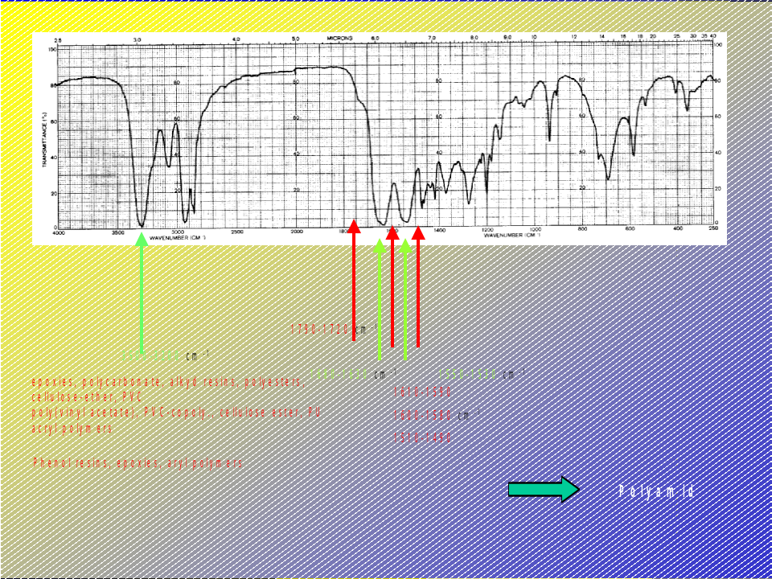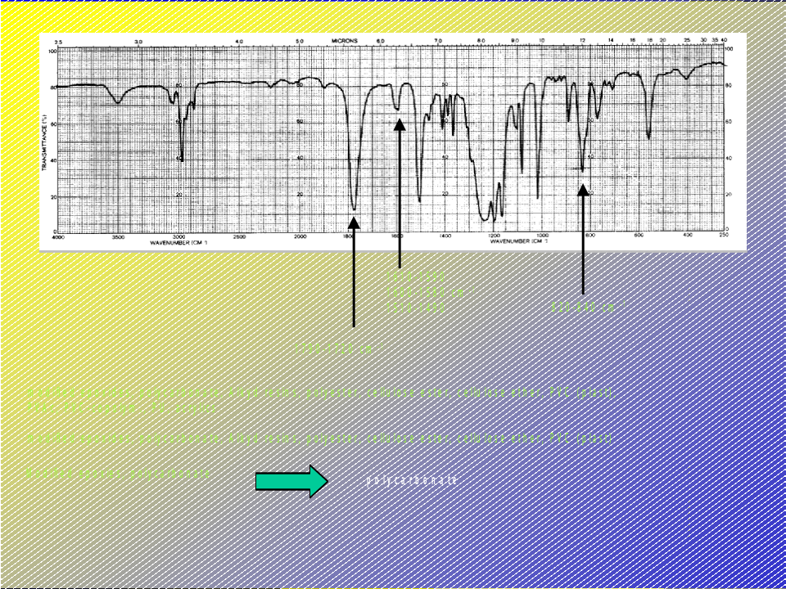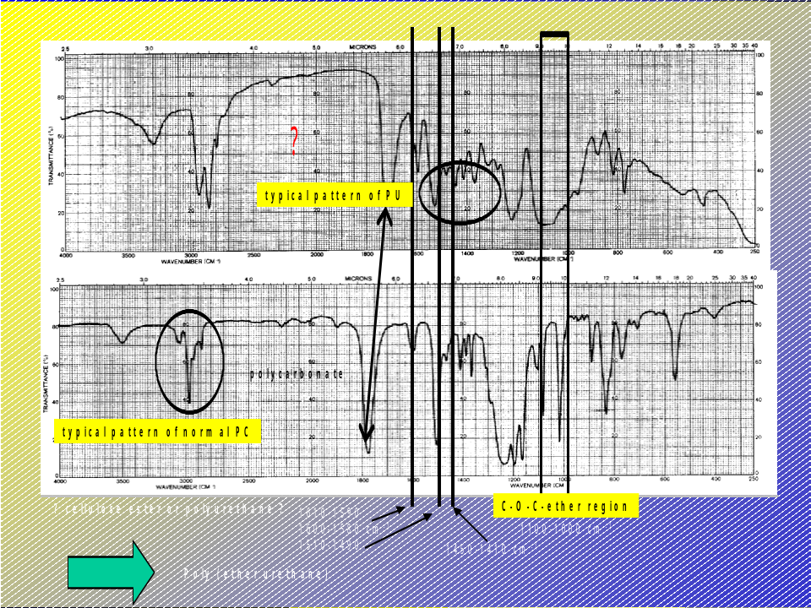

A large amount of spectra of common polymers, special polymers, additives etc. can be found in literature, see bibliography.
If the thickness of a film or the distance of the windows in a cuvette is in the appropriate range it can be measured by the interference pattern that occurs if the surfaces are parallel and smooth. The light reflected between the parallel surfaces of a film causes "fringes" in the spectrum which are frequently undesired. They can be removed by roughening the surface.
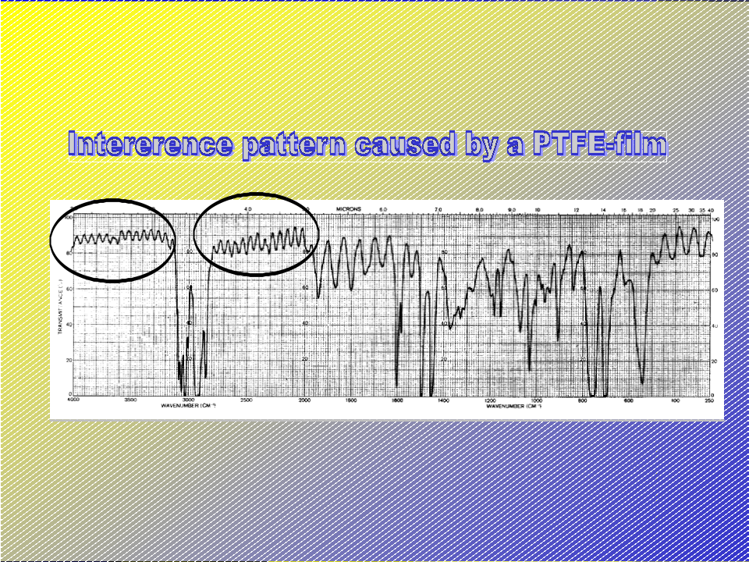
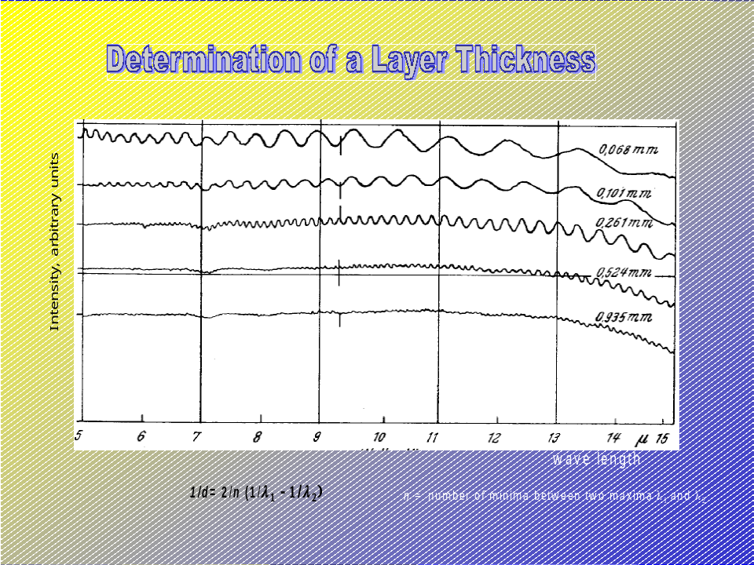

Polarization Fourier transform spectroscopy and 2D-spectroscopy have opened the field of determination of segmental motions and orientation under the influence of external force fields.

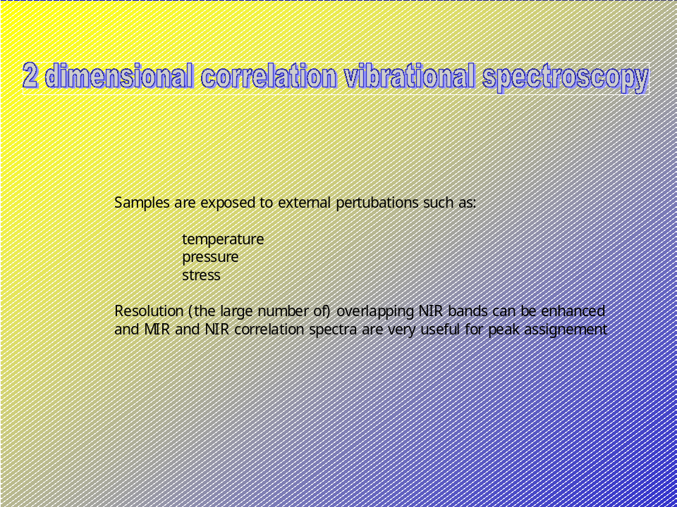

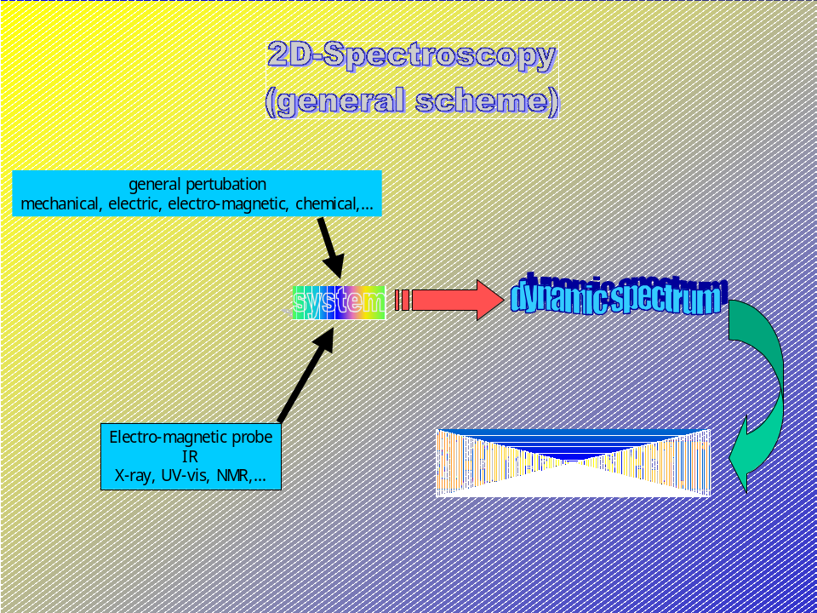

NIR-spectroscopy has recently become an important application of IR-spectroscopy because it can be used in combination with light-fibre optics in on-line probe accessories and high-temperature applications. Besides other applications NIR has been successfully applied to the diffusion of small molecules in a polymeric matrix and rheo-optical vibrational spectroscopy to determine transient structural changes during deformation, information which can hardly be obtained from other techniques.

Bibliography

- Hummel D, Scholl (1968...) Atlas of Polymer Spectroscopy, Wiley-VCh
- Kamowo S, Siesler H W, Ozaki Y, Kawata S (2001) NIR-Spectroscopy: Principles, Instrumentation, Application Wiley-VCh, Weinheim
- Zerbi G (ed) (1999) Modern Polymer Spectroscopy, Wiley-VCh, Weinheim

References ? Lin J, Brown C W (1993) Appl Spectrosc 47, 1720
Siesler H W, Zebger I, Kulinna C, Okretic S, Shilov S, Hoffmann U (1998) in Zerbi G (ed) Modern Polymer Spectroscopy, Wiley-VCh, Weinheim
Noda I, Downrey A E, Marcott C (1998) in Zerbi G (ed) Modern Polymer Spectroscopy, Wiley-VCh, Weinheim
Siesler H W (1998) in Zerbi G (ed) Modern Polymer Spectroscopy, Wiley-VCh, Weinheim

