Dynamic-Mechanical Properties of Polymers

Michael Hess
Department of Physical Chemistry, University Duisburg-Essen, Campus Duisburg, Duisburg, Germany
Department of Polymer Engineering & Science, Chosun University, KwangJu, South Korea
Department of Materials Science, University of North Texas, Denton, Texas, USA

2. EXAMPLES

Most of the examples by courtesy of Kevin Menard (University of North Texas, Department of Materials Science and Perkin Elmer Corp.)
Kevin P. Menard, Dynamic-Mechanical Analysis, CRC-Press (1999) Boca Raton
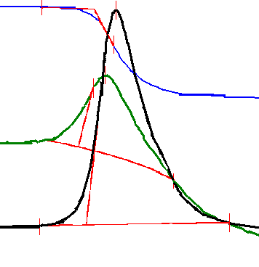
ΔΗ/(J/g)
Heat flow/mW
Temperature /C
Inflection Point
 ΔCp
T_{f}
Onset
Modulus/Pa
Tan δ
Tg by DMA and DSC
Temperature/C
Onset E’ = 133.1 °C
Peak Tan δ = 140.5°C
Onset Tan δ = 130.0 °C
Onset E” = 127.3 °C
Peak E” = 136.7 °C
(a)
(b)
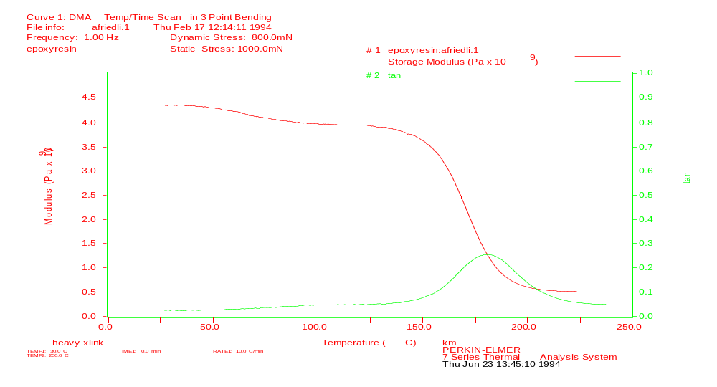
Transitions are clearly seen in highly crosslinked samples
This T_{g} is normally undetectable in the DSC!!!!!! Because the step in cp is broad
and flat (hindered mobility by crosslinking)
Kevin P. Menard, Dynamic-Mechanical Analysis, CRC-Press (1999) Boca Raton

Blends and Copolymers

Kevin P. Menard, Dynamic-Mechanical Analysis, CRC-Press (1999) Boca Raton
Polymer A
Temperature/K
E’
E’
Polymer B
+
=
E’
Temperature/K
Both T_{g}s

Block Copolymers
Graft Copolymers
Immiscible Blends
Random
Copolymers &
Miscible Blends
E’
Single T_{g}
Exact T depends on
concentration of A and B
Temperature/K
Temperature/K
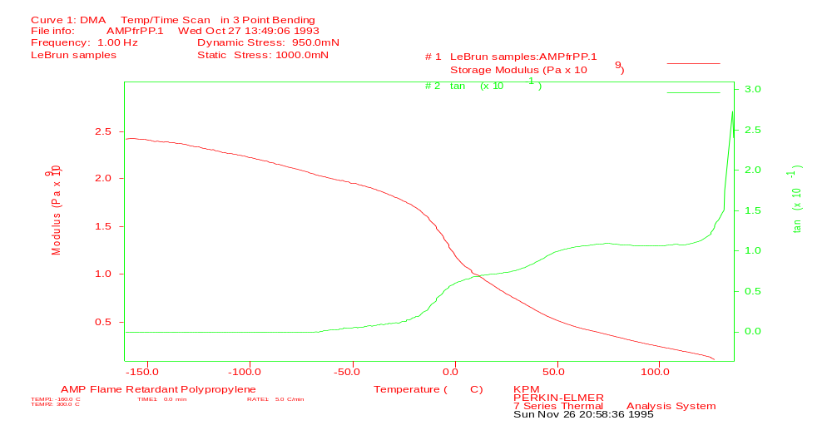

It’s not always so simple:

For example, crystal-crystals slips can cause α∗ transitions
T_{g} or
Alpha
T_{α}*
Kevin P. Menard, Dynamic-Mechanical Analysis, CRC-Press (1999) Boca Raton

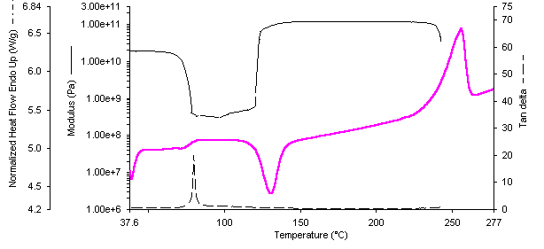
Cold Crystallization in PET
T_{g}
Cold Crystallization
T_{m}
DMTA
DSC
Kevin P. Menard, Dynamic-Mechanical Analysis, CRC-Press (1999) Boca Raton

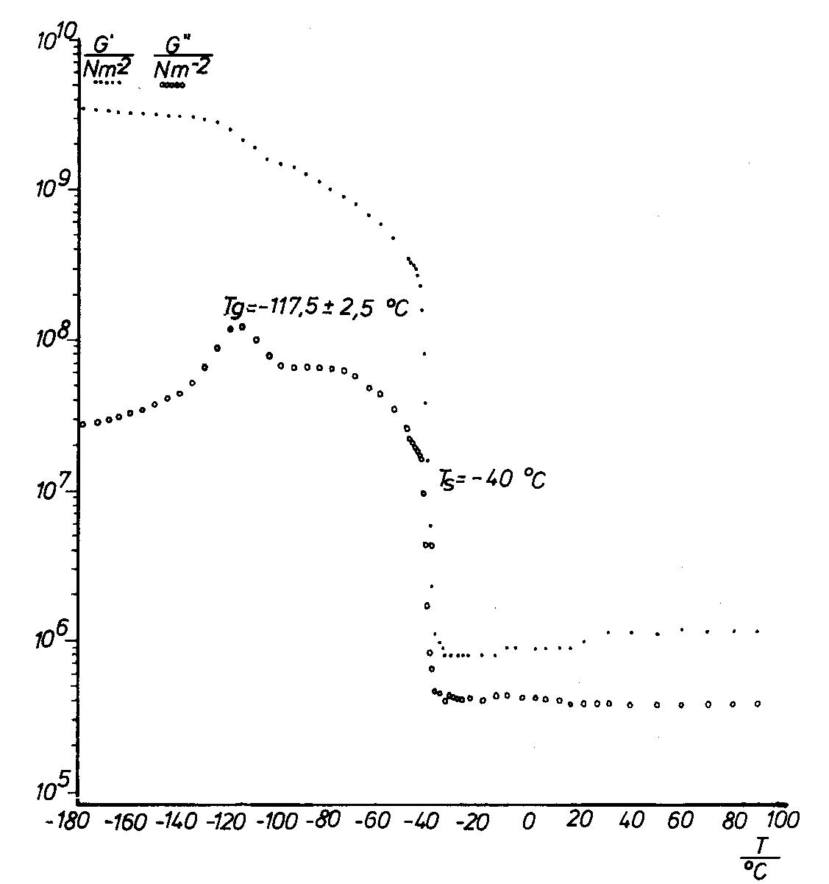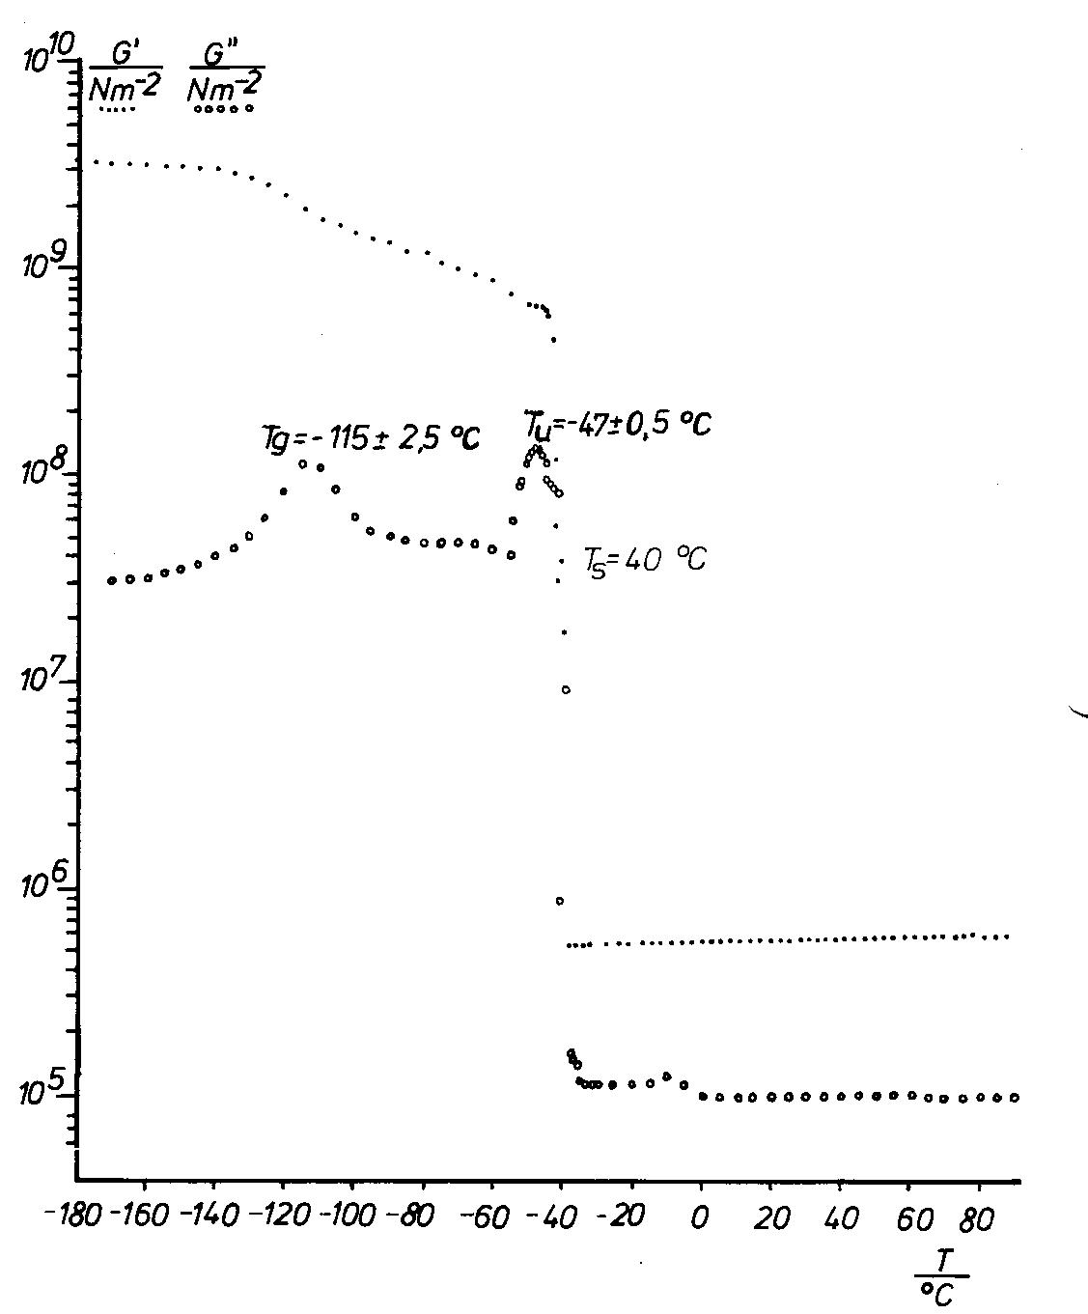
Left: silicon rubber with a glass transition at –117°C and a melting transition at –40°C. Beyond the melting temperature this crosslinked (vulcanised) material shows rubber-elasticity with modulus that increases with the temperature.
Right: also a silicone rubber that contains silicone oil as diluent, as plasticizer. The oil causes a stress-relaxation at the beginning of the melting transition around –47°C.
R. Kosfeld, M. Hess, Progr. Colloid & Polymer Sci. 66 (1979) 43-50

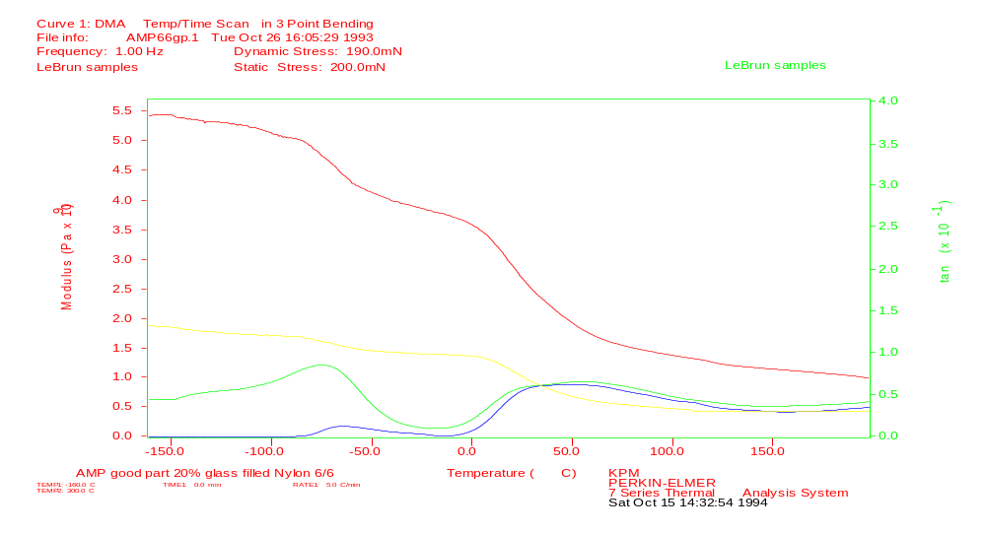

Dissipation of mechanical energy:

Higher Order Transitions affect toughness

β Transitions
T_{g}
Good Impact Strength
Poor
Impact was good if T_{g}/T_{β} was 3 or less.
Kevin P. Menard, Dynamic-Mechanical Analysis, CRC-Press (1999) Boca Raton

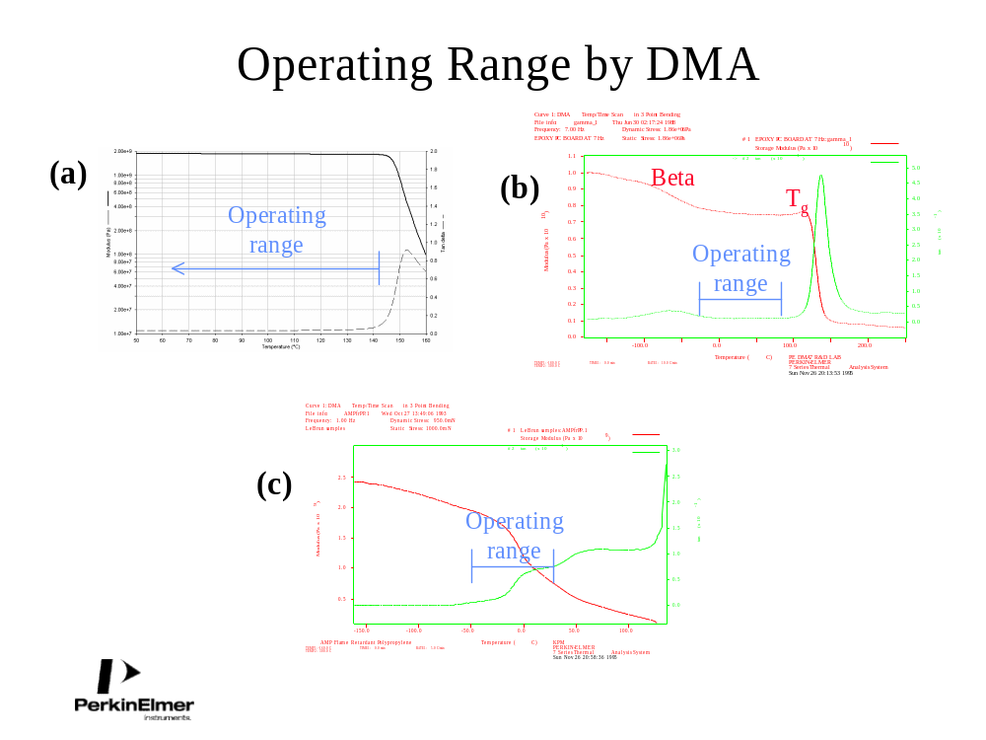
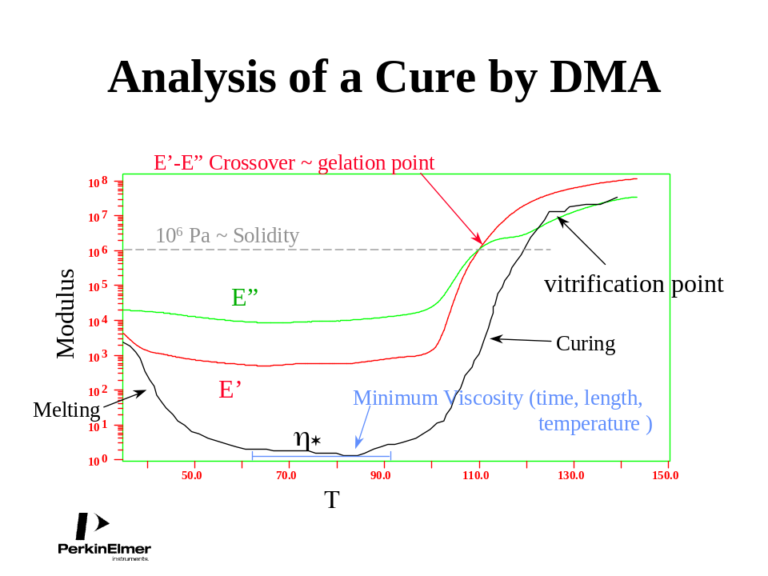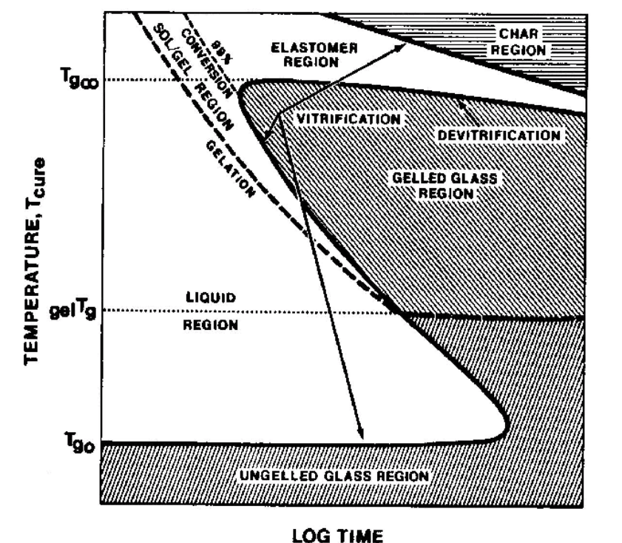
right figure after J. K. Gillham, Encyclop. Polym. Sci. Technol. (1986) 2nd ed.; J. K. Gillham, Polym. Eng. Sci. (1979) 19, 676
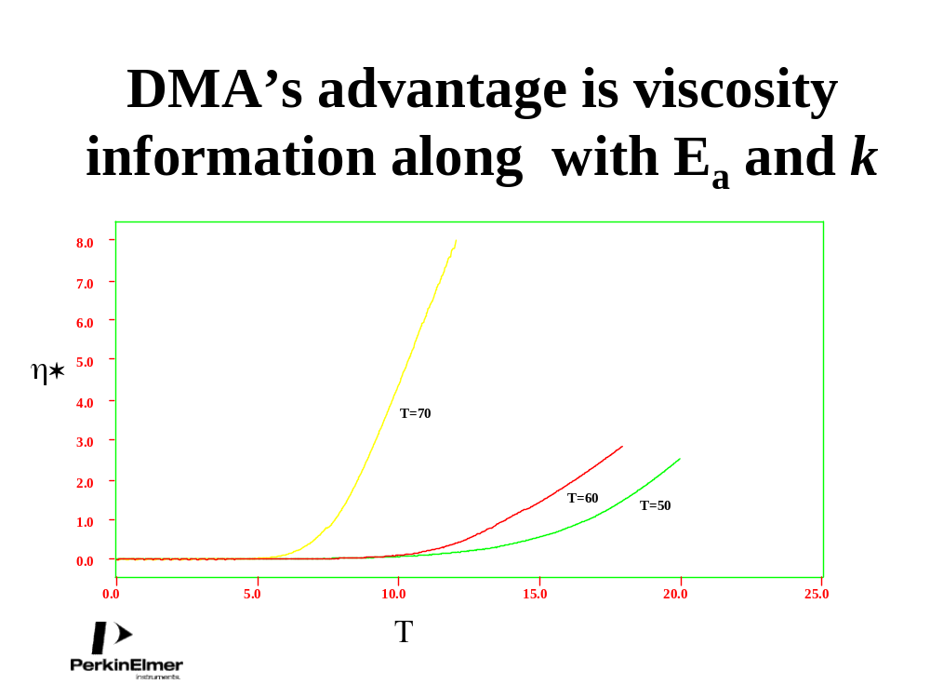
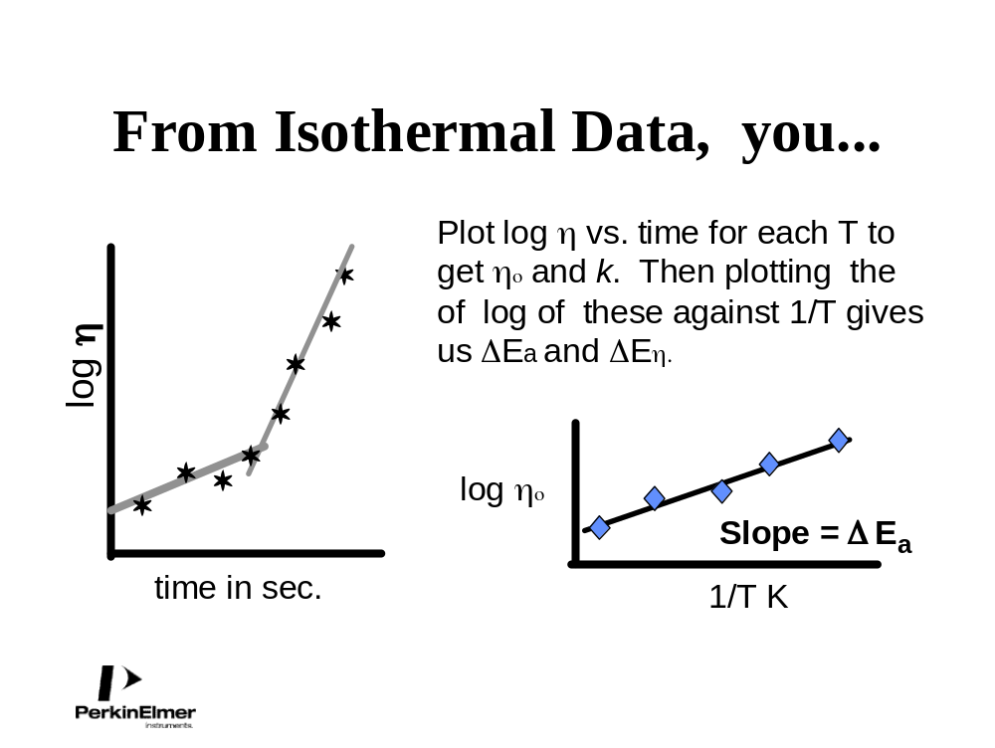
Kevin P. Menard, Dynamic-Mechanical Analysis, CRC-Press (1999) Boca Raton

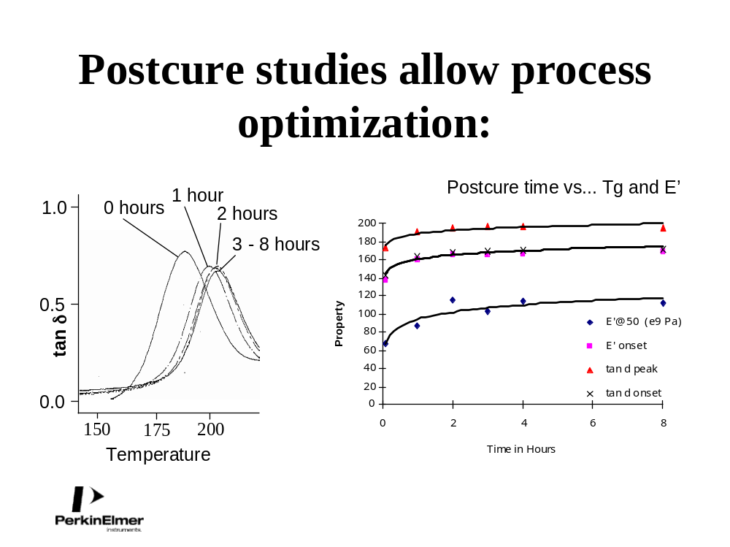
Kevin P. Menard, Dynamic-Mechanical Analysis, CRC-Press (1999) Boca Raton
Kevin P. Menard, Dynamic-Mechanical Analysis, CRC-Press (1999) Boca Raton

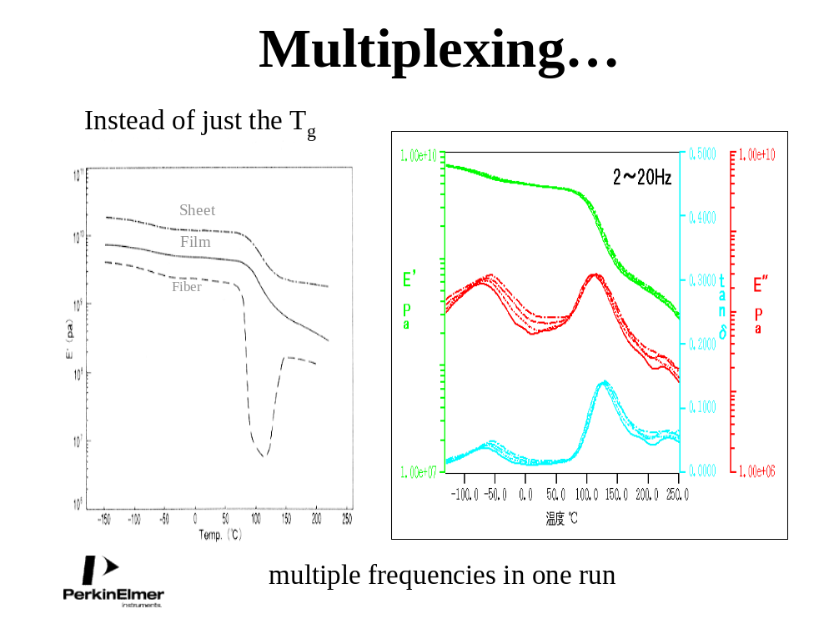
Kevin P. Menard, Dynamic-Mechanical Analysis, CRC-Press (1999) Boca Raton
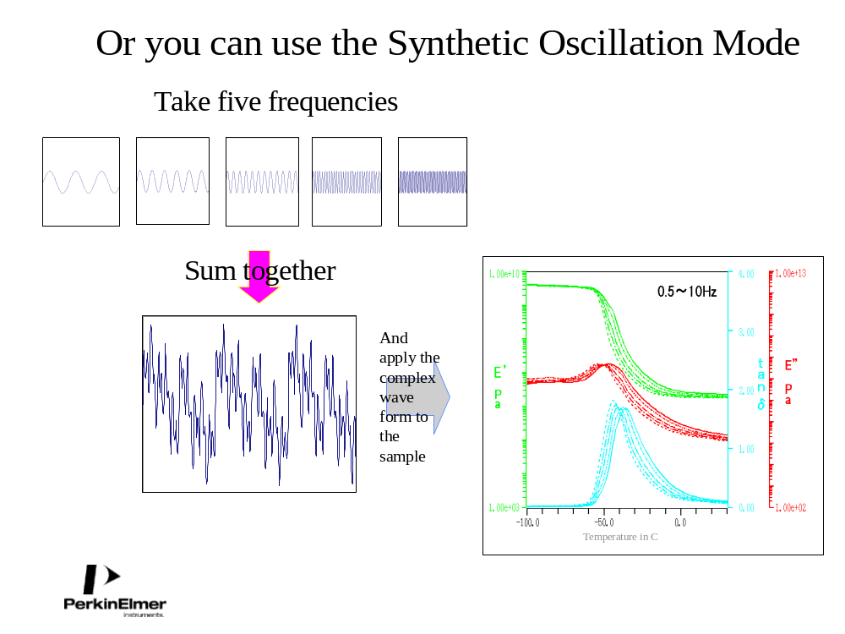

Kevin P. Menard, Dynamic-Mechanical Analysis, CRC-Press (1999) Boca Raton
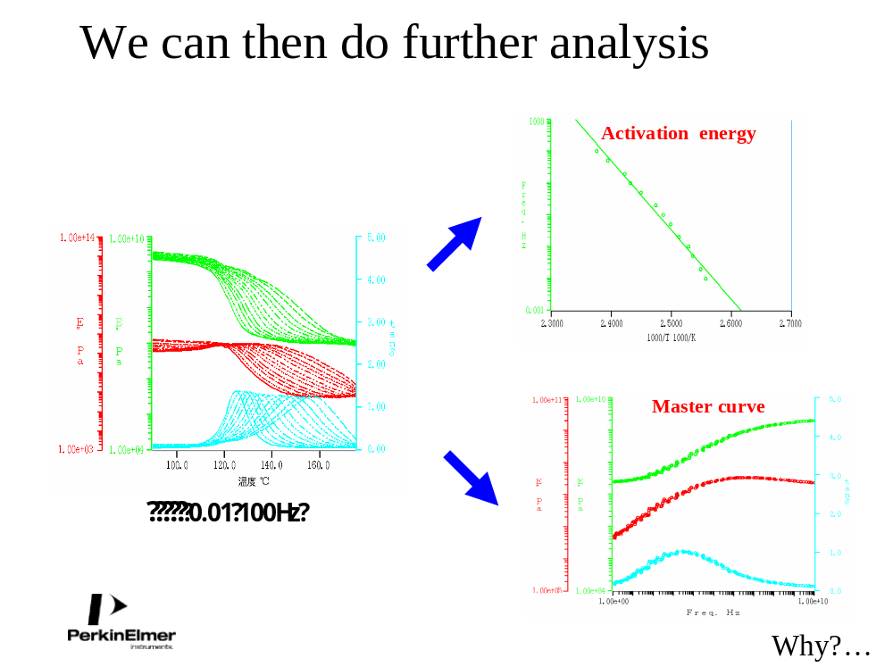
Kevin P. Menard, Dynamic-Mechanical Analysis, CRC-Press (1999) Boca Raton





